
GEETHANJALI INSTITUTE OF SCIENCE & TECHNOLOGY
Unit of USHODAYA EDUCATIONAL SOCIETY
(Approved by AICTE, New Delhi & Permanently Affiliated to JNTUA, Anantapur
JNTUA College Code: 2U 3rd Mile, Bombay Highway, Gangavaram (V), Kovur(M), SPSR Nellore (Dt), Andhra Pradesh,
India- 524137, Ph. No. 08622-212769, E-Mail: geethanjali@gist.edu.in, Website: www.gist.edu.in

OBJECT ORIENTED ANALYSIS AND DESIGN
&
SOFTWARE TESTING

LAB MANUAL



Department of
COMPUTER SCIENCE AND ENGINEERING


GEETHANJALI INSTITUTE OF SCIENCE & TECHNOLOGY
GANGAVARAM (V), KOVUR (M), NELLORE-524137

VISION

- To emerge as a leading Engineering institution imparting quality education

MISSION
- Effective teaching-learning strategies for quality education
- Congenial academic ambience for progressive learning
- Skill development through Industry-Institute initiatives
- Nurturing environmentally conscious and socially responsible technocrats

QUALITY POLICY

To self-prescribe exacting standards of Academic excellence, continuously strive towards accomplishing quality teaching learning opportunities and providing student associated services.

DEPARTMENT OF COMPUTER SCIENCE & ENGINEERING

VISION

- To develop as a lead learning resource centre producing skilled professionals

MISSION
- DM₁ Provide dynamic and application oriented education through advanced teaching learning methodologies
- DM₂ Create sufficient physical infrastructural facilities to enhance learning
- DM₃ Strengthen the professional skills through effective Industry- Institute Interaction
- DM₄ Organize personality development activities to inculcate life skills and ethical values

OBJECT ORIENTED ANALYSIS AND DESIGN & SOFTWARE TESTING LABORATORY
(15A05509)
Course Objectives:
- Practice the notation for representing various UML diagrams
- Analyze and design the problem by representing using UML diagrams
- Become familiar with all phases of OOAD
List of Experiments: (All the Experiments are to be conducted)
Part A: OOAD Lab

UML diagrams to be developed are:
a. Use Case Diagram.
b. Class Diagram.
c. Sequence Diagram.
d. Collaboration Diagram.
e. State Chart Diagram.
f. Activity Diagram.
g. Component Diagram.
h. Deployment Diagram.
Problems that may be considered are
1. College Information System
2. Hostel Management System
3. ATM system
Additional Experiments:
4. Library Management System
5. Online Banking System

Part B : Software Testing Lab

1) Write programs in C Language to demonstrate the working of the following
constructs:
i) do...while ii) while….do iii) if…else iv) switch v) for

2) A program written in C language for Matrix Multiplication fails Introspect the
causes for its failure and write down the possible reasons for its failure.

3) Take any system (e.g. ATM system) and study its system specifications and
report the various bugs.

4) Write the test cases for any known application (e.g. Banking application)

5) Create a test plan document for any application (e.g. Library Management
System)

6) Study of Win Runner Testing Tool and its implementation

Additional Experiment:

7) Write the test cases for any Login page of any website (e.g. GMAIL application )

OOAD LAB

INTRODUCTION

USECASE DIAGRAM:
A behavioral diagram that shows a set of use cases and actors and their relation ships.

USECASE:
It is a description of set of sequence of actions that a system performs that yields an observable result of value to a particular actor.
A use case is used to structure the behavioral things in a model and it is rendered as an ellipse with solid line along with its name.

Actor:
It specifies a coherent set of roles that users of use cases play when interacting with these use cases.

CLASS DIAGRAM:
A structural diagram that shows a set of classes, interfaces, collaborations, and their relationships.

OBJECT DIAGRAM:
A structural diagram that shows a set of objects and their relationships.

SEQUENCE DIAGRAM:
A behavioral diagram that shows an interaction, emphasizing the time ordering of messages.

COLLABORATION DIAGRAM:
A behavioural diagram that shows an interaction, emphasizing the structural organization of the objects that send and receive meassages.

STATECHART DIAGRAM:
A behavioural diagram that shows a state machine, emphasizing the event-ordered behavior of an object.

ACTIVITY DIAGRAM:
An activity diagram represents the execution state of a mechanism as a sequence of steps grouped sequentially as parallel conrol flow branches.It is a variant of state chart diagrams organized according to actions and internal behavior of a method or a usecase.
Activity diagram s are used to model the dynamic aspects of system.
➔ Swimlanes
➔ Forking
➔ Joining

COMPONENT DIAGRAM:
Component diagrams are basically used to model static view of the system. This can be achieved by modeling various physical components like libraries, tables, and files etc. which are residing within a node. Component diagrams are very essential for constructing executable systems. This can be done using concepts of forward and reverse engineering. The graphical representation of a component diagrams basically include collection of vertices and arcs.

DEPLOYMENT DIAGRAM:
Deployment is the stage of development that describes the configuration of the running system in a real time environment. For deployment, decisions should be made about configuration parameters, performance, resource allocation, distribution and concurrency. The component develop or reused should be deployed on some set o f hardware for execution. Nodes are used to model the topology of the hardware on which the system executes. A node usually represents a processor or a device on which components can be deployed.

Exp.No. 1 | COLLEGE INFORMATION SYSTEM
Dt. | COLLEGE INFORMATION SYSTEM

AIM: UML Diagrams for College Information System.
PROBLEM DEFINITION:

College management system is an integrated web application that handles various academic and non academic activities of a College/Academic Institute. There are many departments of administration for the maintenance of college information and student databases in any institution. All these departments provide various records regarding students. Most of these track records need to maintain information about the students. This information could be the general details like student name, address, performance; attendance etc or specific information related to departments like collection of data. All the modules in college administration are interdependent. They are maintained manually. So they need to be automated and centralized as, Information from one module will be needed by other modules.
This is a web-related application that permits us to approach the entire knowledge regarding the college, employees, students, faculties etc. This application is also called as institute management system. It offers an actual trip of the college campus. Here we would gain the recent knowledge regarding the students and employees. This general application planned for aiding the students of an organization about details on the courses, subjects, classes, assignments, grades and time-table.

Admin can add person, delete person, can give special permission. Admin can schedule classes, their lectures time. Teachers can get information of any students under their particular class. Teachers can also make query by using grade, percentage, can see list of students who comes under the category of attendance shortage and many more under this one roof.
A. USECASE DIAGRAM

- A use case diagram is a diagram that shows a set of use cases and actors and their relationships.
- A use case diagram shows a set of use cases and actors and their relationships
- Use case diagrams address the static use case view of a system.
- These diagrams are especially important in organizing and modeling the behaviors of a system.

Contents:

- Use case diagrams commonly contain
    - Use cases
    - Actors
    - Dependency, generalization, and association relationships
- Like all other diagrams, use case diagrams may contain notes and constraints.
- Use case diagrams may also contain packages
- Occasionally, you'll want to place instances of use cases in your diagrams, as well, especially when you want to visualize a specific executing system.

Common Uses:

- We apply use case diagrams to model the static use case view of a system. This view primarily supports the behavior of a system
- When you model the static use case view of a system, you'll typically apply use case diagrams in one of two ways.
  - To model the context of a system
  - To model the requirements of a system

Usecase Diagram for College Information System
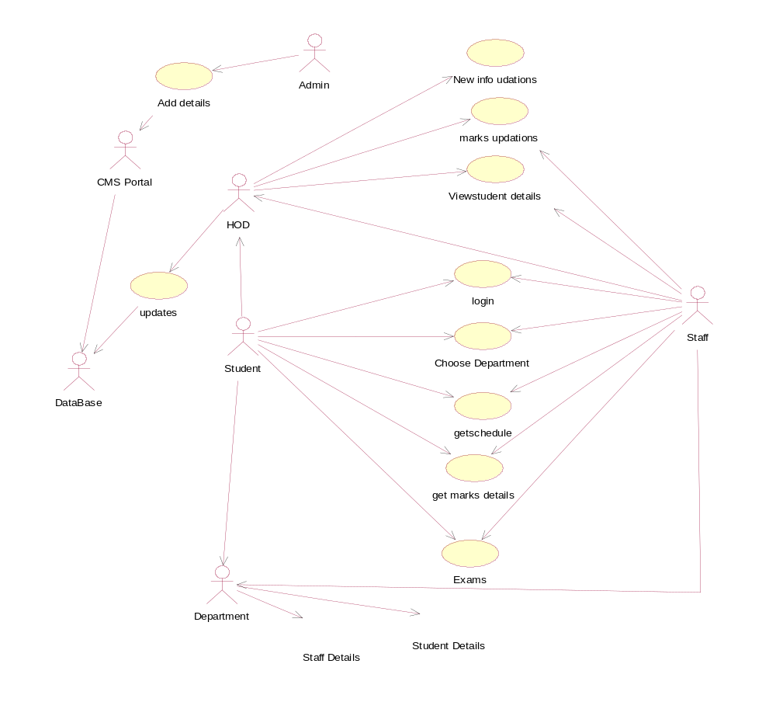
B. CLASS DIAGRAM
A class diagram shows a set of classes, interfaces, and collaborations and their relationships. Graphically, a class diagram is a collection of vertices and arcs.

Contents:
Class diagrams commonly contain the following things:
  - Classes
  - Interfaces
  - Collaborations
  - Dependency, generalization, and association relationships
- Like all other diagrams, class diagrams may contain notes and constraints
- Class diagrams may also contain packages or subsystems
Common Uses:

- To model the vocabulary of a system
- To model simple collaborations
- To model a logical database schema

Class diagram for College Information system

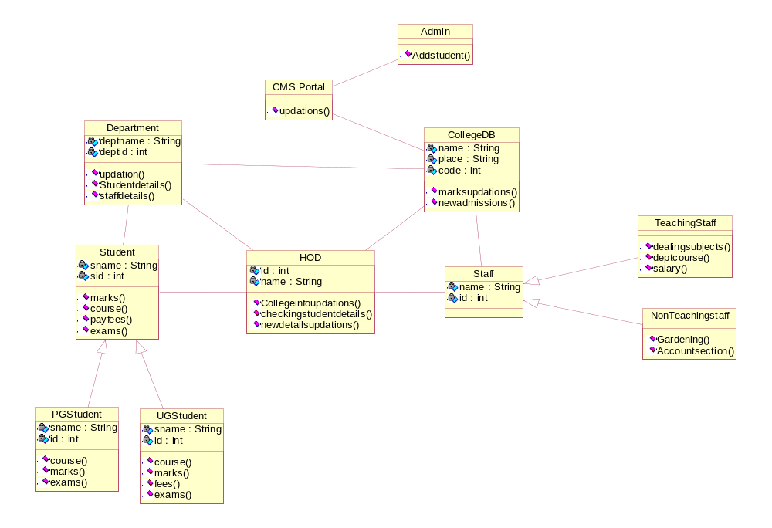

C. SEQUENCE DIAGRAM

- A sequence diagram is an interaction diagram that emphasizes the time-ordering of messages
- In the UML, the first kind of representation is called a sequence diagram
- Sequence diagrams permit you to model the lifeline of an object.
- Seqence diagram emphasises the time ordering of messages.

Contents:
- Objects
- Messages
- Life lines
- Focus of control
- Forward messages
- Backward messages
- Self messages
Common Uses:
We use interaction diagrams to model the dynamic aspects of a system. You do so in the context of the system as a whole , subsystem, operation , class or usecase.
- We'll typically use interaction diagrams in one of two ways:
- To model the flow of control by time ordering of messages
- To model the flow of control by organization

Sequence Diagram for College Information System

Sequence Diagram For Adding Student:

Main Flow:

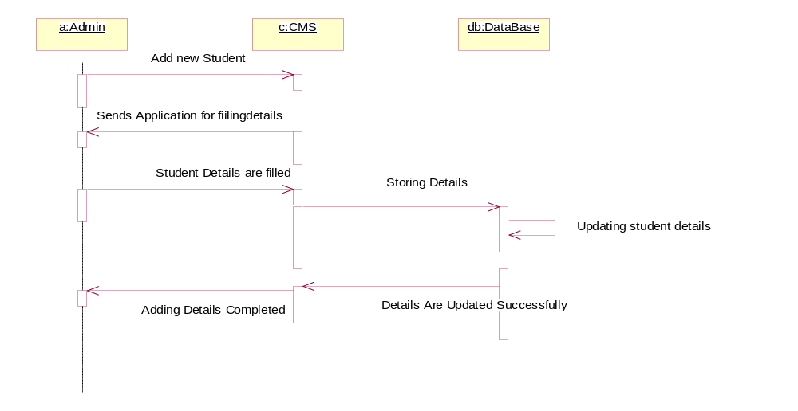
Sequence Diagram for add new student:
Alternative flow:

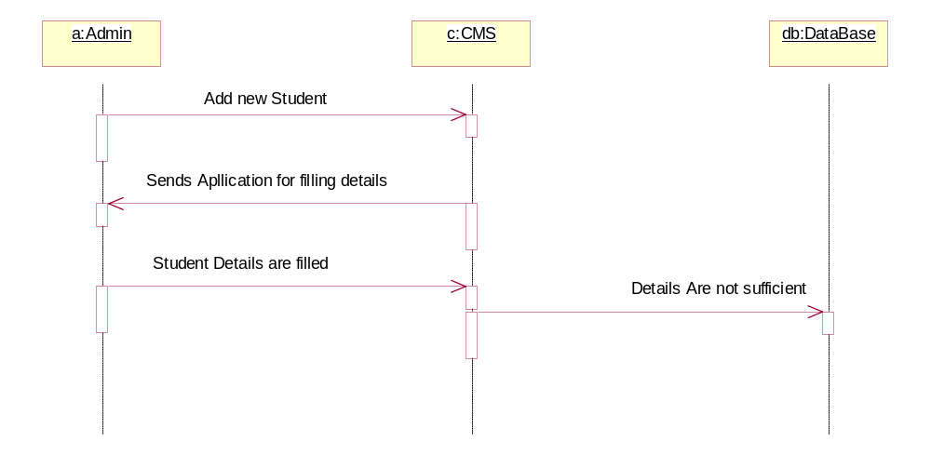

D. COLLABORATION DIAGRAM

- A collaboration diagram is an interaction diagram that emphasizes the structural organization of the objects that send and receive messages.
    - Collaboration diagrams permit you to model the structural links that may exist among the objects in an interaction.Sequence diagrams and collaboration diagrams are isomorphic, meaning that you can take one and transform it into the other
The second kind of representation is called a collaboration diagram.
- These diagrams are for modeling dynamic aspects of the system.

Contents properties:

- an interaction diagram is just a special kind of diagram that shares the name and graphical contents of other diagrams
- Iinteraction diagram distinquishes with other diagrams is its content.

Contents:
Interaction diagrams commonly contains
- Objects
- Links
- Messages
Like all other diagrams, interaction diagram may contains notes and constraints
Common Uses:
- You use interaction diagrams to model the dynamic aspects of a system. You do so in the context of the system as a whole , subsystem, operation , class or usecase.
- We'll typically use interaction diagrams in one of two ways:
- To model the flow of control by time ordering of messages
- To model the flow of control by organization

Collaboration Diagram for College Information system
Mainflow:

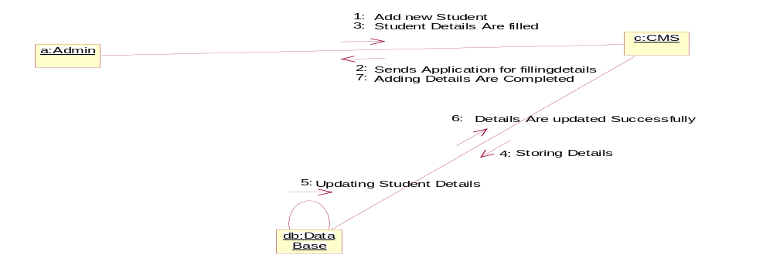

Alternative flow:
- 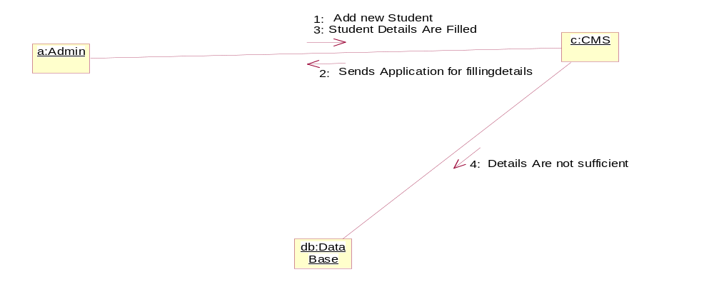

E. STATECHART DIAGRAM

A statechart diagram shows a state machine, consisting of states, transitions, events, and activities
- Statechart diagrams address the dynamic view of a system
- State diagrams are one of the five diagrams in the UML for modeling the dynamic aspects of system.

Common Properties:
A state diagram is just a special diagram and shares the same common properties as do all other diagrams is a name and graphical content that are a projection into a model
- A state diagram distinguishes the all other diagrams is its contents.

Contents:
State diagrams commonly contain
- Simple states and composite states
- Transitions, events, and actions
Like all other diagram, state diagrams may contain notes and constraints
Common uses:
State diagrams to model the dynamic aspects of a system, a class, a usecase.
- To model reactive objects

Statechart Diagram for College Information system
Admins Logins
Add new Student
Student Details Are Filled
Adding Details Are Completed
Logout

Updating Those Details

New Details are available then Update

F. ACTIVITY DIAGRAM

- An activity diagram shows the flow from activity to activity. Activity is an ongoing nonatomic execution within a state machine.
- Activities ultimately result in some action, which is made up of executable atomic computations that result in a change in state of the system or the return of a value.
- Actions encompass calling another operation, sending a signal, creating or destroying an object, or some pure computation, such as evaluating an expression.
- Graphically, an activity diagram is a collection of vertices and arcs.
- Activity diagrams address the dynamic view of a system.

Contents:

- Activity diagrams commonly contain
  - Activity states and action states
  - Transitions
  - Objects
- Like all other diagrams, activity diagrams may contain notes and constraints.

Common Uses:

- We use activity diagrams to model the dynamic aspects of a system
- These dynamic aspects may involve the activity of any kind of abstraction in any view of a system's architecture, including classes, interfaces, components, and nodes.
- When you model the dynamic aspects of a system, we'll typically use activity diagrams in two ways.
    - To model a workflow
    - To model an operation
Activity Diagram for College Information System:

Admin log into CMS portal

Admin add new student
CMS portal sends an application form

Admin fills student details

Student details are stored in database
Details are not sufficient

Details are sufficient

Existing of new details
New details are not available

New details available
Update database

Adding details completed

Logout

G. COMPONENT DIAGRAM
A component diagram shows the organizations and dependencies among a set of components.
A component diagram shows a set of components and their relationships. Graphically, a component diagram is a collection of vertices and arcs.
- Component diagrams address the static implementation view of a system
- They are related to class diagrams in that a component typically maps to one or more classes, interfaces, or collaborations.

Contents:

Component diagrams commonly contain
- Components
- Interfaces
- Dependency, generalization, association, and realization relationships. Like all other diagrams, component diagrams may contain notes and constraints.
Common Uses:
When you model the static implementation view of a system, you'll typically use component diagrams in one of four ways.
1. To model source code
2. To model executable releases
3. To model physical databases
4. To model adaptable systems

Component Diagram for College Information System

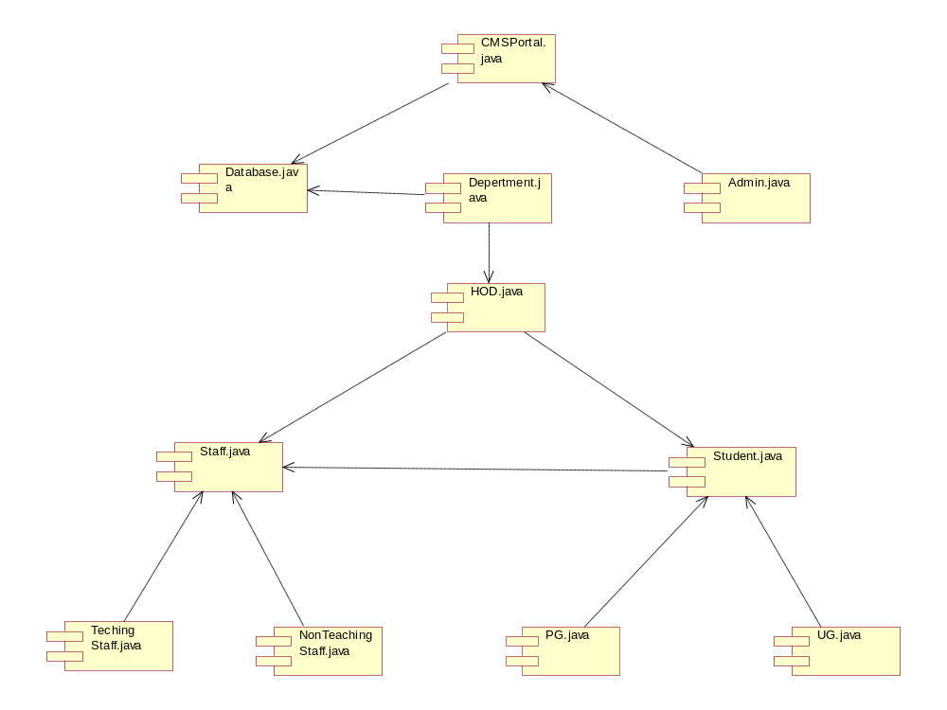

H. DEPLOYMENT DIAGRAM
- A deployment diagram is a diagram that shows the configuration of run time processing nodes and the components that live on them. Graphically, a deployment diagram is a collection of vertices and arcs.
- A deployment diagram shows the configuration of run-time processing nodes and the components that live on them
- Deployment diagrams address the static deployment view of an architecture

Common properties:
A deployment diagram is just a special kind of diagram and shares the same common properties as all other diagrams• a name and graphical contents that are a projection into a model. What distinguishes a deployment diagram from all other kinds of diagrams is its particular content.
Contents:
Deployment diagrams commonly contain
- Nodes
- Dependency and association relationships
Like all other diagrams, deployment diagrams may contain notes and constraints.
Common Uses:
1. To model embedded systems
2. To model client/server systems
3. To model fully distributed systems
Deployment Diagram for College Information System
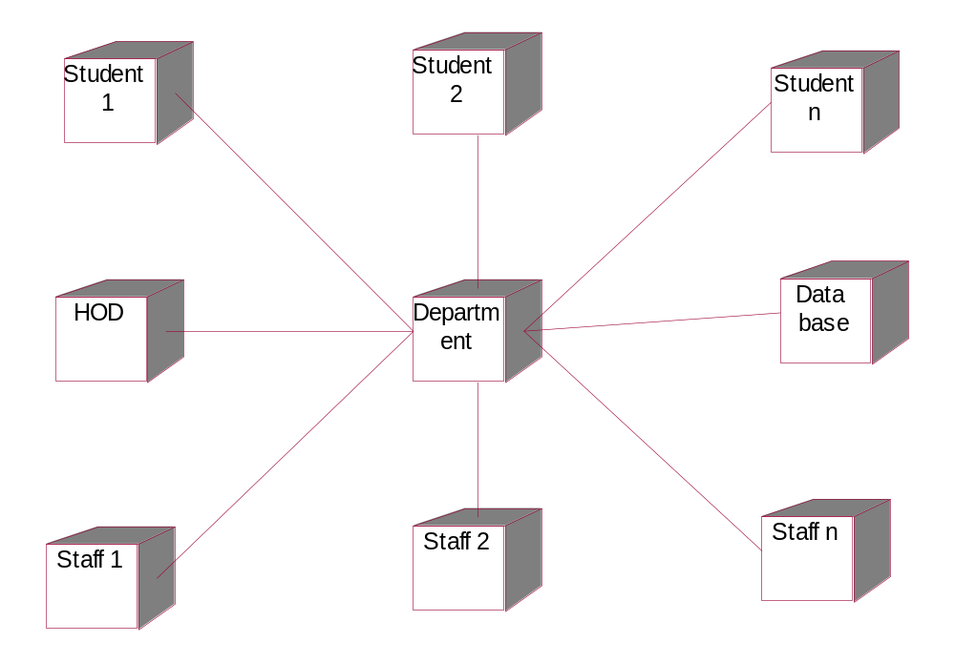
Result: Thus the diagrams (Use Case Diagram, Class Diagram, Sequence Diagram, Collaboration Diagram, State Chart Diagram, Activity Diagram, Component Diagram, and Deployment Diagram) for the College Information System has been designed, executed and output is verified.
Exp.No. 2 | Hostel Management System
Dt. | Hostel Management System

AIM: UML Diagrams for Hostel Management System.
PROBLEM DEFINITION:

Hostel management by manual way is tedious process, since it involves work load and time consumption. In this system, we can easily manage the hostel details, room details, student records, mess expenditure, mess bill calculation, easy way of room allocation and hostel attendance. The main feature of this project is easy to allocate for the student and also easy to calculate mess bill.

As the name specifies “HOSTEL MANAGEMENT SYSTEM” is software developed for managing various activities in the hostel. Identification of the drawbacks of the existing system leads to the development of computerized hostel management system that will be compatible to the existing system with the system which is more users friendly and more GUI oriented. We can improve the efficiency of the system, thus overcome the drawbacks of the existing hostel management system. Less human error, Strength and strain of manual labor can be reduced, High security, Data redundancy can be avoided to some extent, Data consistency, Easy to handle, Easy data updating, Easy record keeping, Backup data can be easily generated.

Hostel Management System provides the facility to the employee that they can check which one paid the mess bill and how much is due .this software project can also check that to whom the room has been allocated and the vacant room.

A. USECASE DIAGRAM

- A use case diagram is a diagram that shows a set of use cases and actors and their relationships.
- A use case diagram shows a set of use cases and actors and their relationships
- Use case diagrams address the static use case view of a system.
- These diagrams are especially important in organizing and modeling the behaviors of a system.

Contents:

- Use case diagrams commonly contain
    - Use cases
    - Actors
    - Dependency, generalization, and association relationships
- Like all other diagrams, use case diagrams may contain notes and constraints.
- Use case diagrams may also contain packages
- Occasionally, you'll want to place instances of use cases in your diagrams, as well, especially when you want to visualize a specific executing system.

Common Uses:

- We apply use case diagrams to model the static use case view of a system. This view primarily supports the behavior of a system
- When you model the static use case view of a system, you'll typically apply use case diagrams in one of two ways.
  - To model the context of a system
  - To model the requirements of a system

Usecase Diagram for Hostel Management System

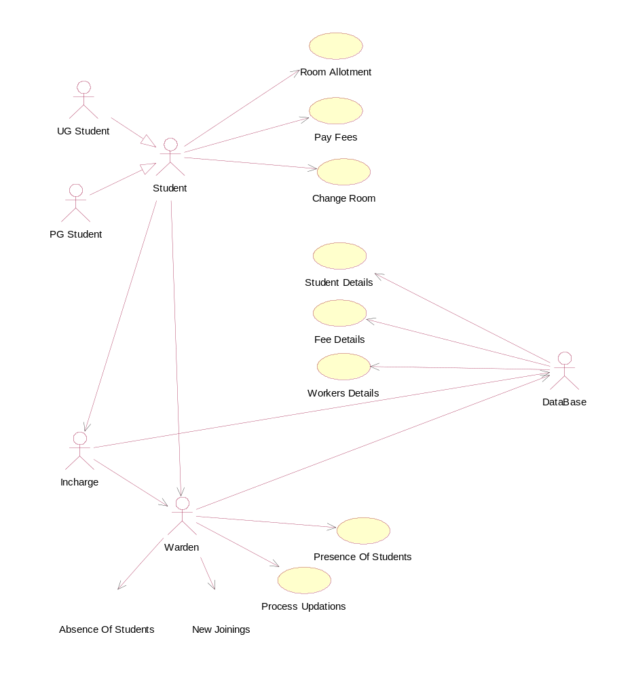

B. CLASS DIAGRAM

A class diagram shows a set of classes, interfaces, and collaborations and their relationships. Graphically, a class diagram is a collection of vertices and arcs.

Contents:

C::Class diagrams commonly contain the following things:
  - Classes
  - Interfaces
  - Collaborations
  - Dependency, generalization, and association relationships

- Like all other diagrams, class diagrams may contain notes and constraints
- Class diagrams may also contain packages or subsystems

Common uses:

- To model the vocabulary of a system
- To model simple collaborations
- To model a logical database schema

Class Diagram for Hostel Management System

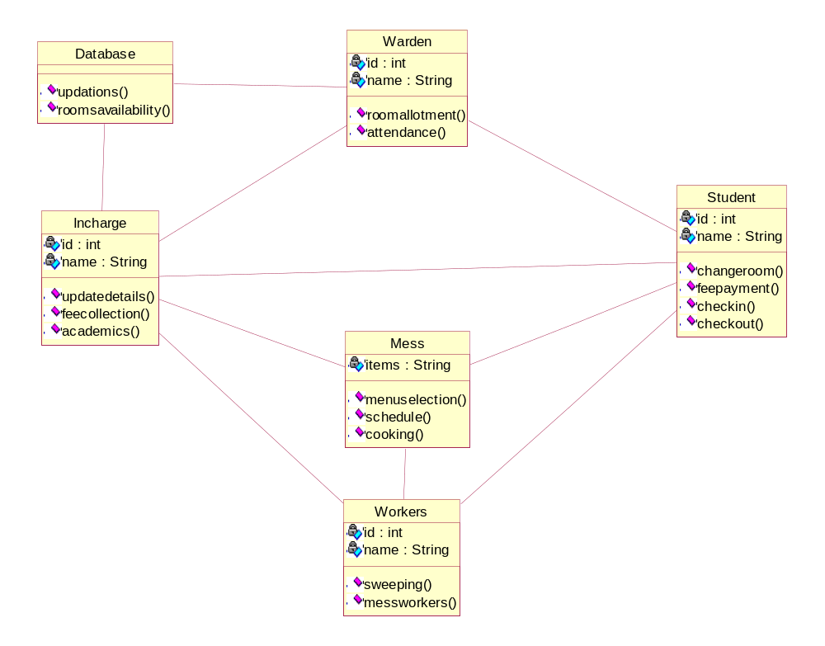

C. SEQUENCE DIAGRAM

- A sequence diagram is an interaction diagram that emphasizes the time-ordering of messages
- In the UML, the first kind of representation is called a sequence diagram
- Sequence diagrams permit you to model the lifeline of an object.
- Sequence diagram emphasizes the time ordering of messages.

Contents:
- Objects
- Messages
- Life lines
- Focus of control
- Forward messages
- Backward messages
- Self messages
Common Uses:
We use interaction diagrams to model the dynamic aspects of a system. You do so in the context of the system as a whole , subsystem, operation , class or usecase.
- We'll typically use interaction diagrams in one of two ways:
- To model the flow of control by time ordering of messages
- To model the flow of control by organization

Sequence Diagram for Hostel management System

Main flow:

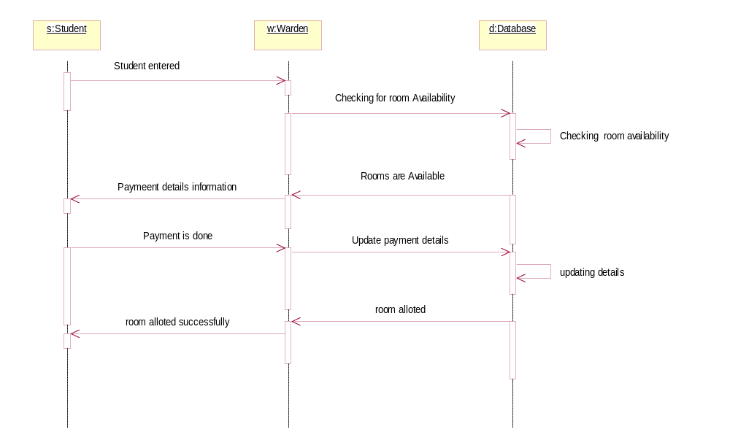

Alternative flow:

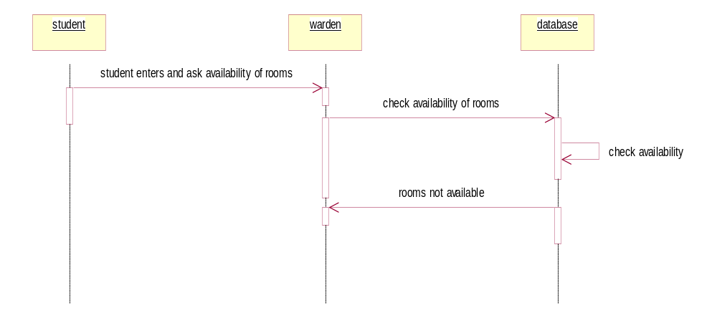
D. COLLABORATION DIAGRAM

- A collaboration diagram is an interaction diagram that emphasizes the structural organization of the objects that send and receive messages.
    - Collaboration diagrams permit you to model the structural links that may exist among the objects in an interaction.Sequence diagrams and collaboration diagrams are isomorphic, meaning that you can take one and transform it into the other
The second kind of representation is called a collaboration diagram.
- These diagrams are for modeling dynamic aspects of the system.

Common properties:

- an interaction diagram is just a special kind of diagram that shares the name and graphical contents of other diagrams
- Iinteraction diagram distinquishes with other diagrams is its content.

Contents:
Interaction diagrams commonly contains
- Objects
- Links
- Messages
Like all other diagrams, interaction diagram may contain notes and constraints.
Common uses:
- You use interaction diagrams to model the dynamic aspects of a system. You do so in the context of the system as a whole, subsystem, operation, class or usecase.
- We'll typically use interaction diagrams in one of two ways:
- To model the flow of control by time ordering of messages
- To model the flow of control by organization

Collaboration diagram for Hostel management System

Main flow:

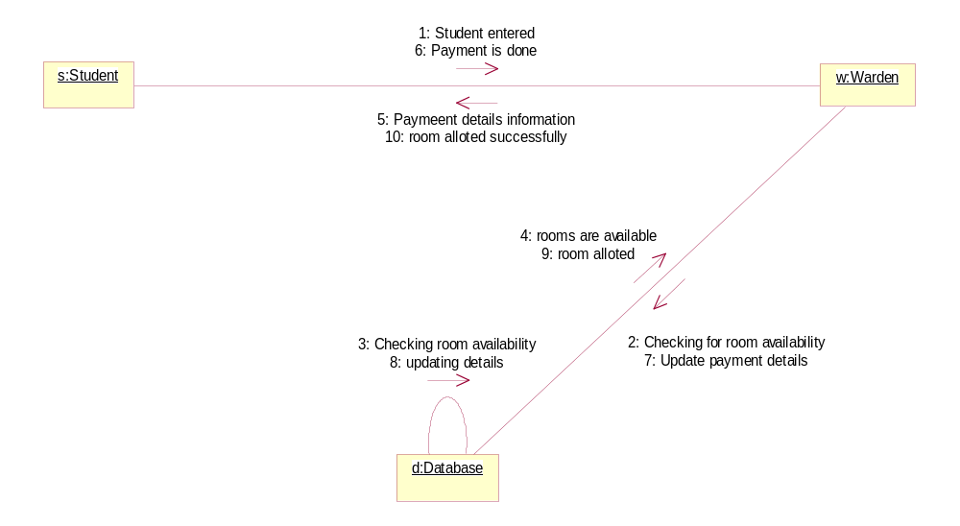

Alternative flow:
- 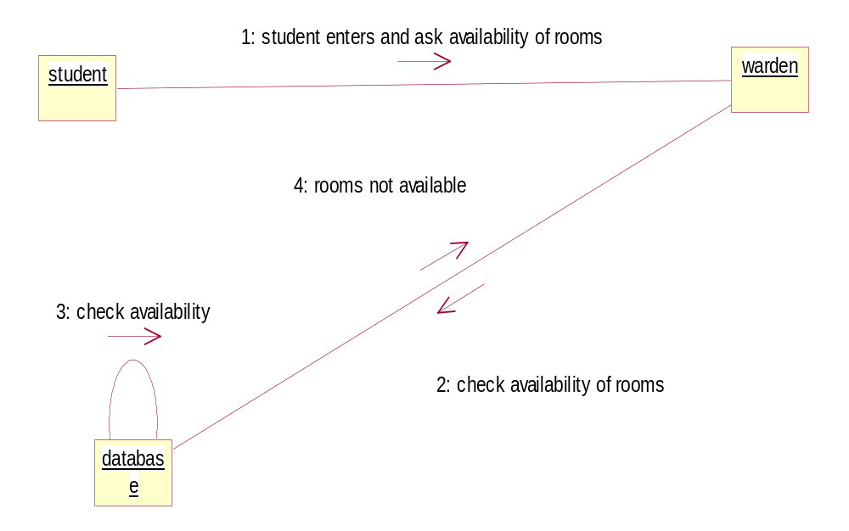

E. STATECHART DIAGRAM

A statechart diagram shows a state machine, consisting of states, transitions, events, and activities
- Statechart diagrams address the dynamic view of a system
- State diagrams are one of the five diagrams in the UML for modeling the dynamic aspects of system.

Common Properties:
A state diagram is just a special diagram and shares the same common properties as do all other diagrams is a name and graphical content that are a projection into a model
- A state diagram distinguishes the all other diagrams is its contents.

Contents:
State diagrams commonly contain
- Simple states and composite states
- Transitions, events, and actions
Like all other diagram, state diagrams may contain notes and constraints
Common uses:
State diagrams to model the dynamic aspects of a system, a class, a usecase.
- To model reactive objects
Statechart Diagram for Hostel Management system

rooms
Pay amount
Check availability of rooms
Student entered and ask availability of rooms
Room alloted
Change room

F. ACTIVITY DIAGRAM

- An activity diagram shows the flow from activity to activity. Activity is an ongoing nonatomic execution within a state machine.
- Activities ultimately result in some action, which is made up of executable atomic computations that result in a change in state of the system or the return of a value.
- Actions encompass calling another operation, sending a signal, creating or destroying an object, or some pure computation, such as evaluating an expression.
- Graphically, an activity diagram is a collection of vertices and arcs.
- Activity diagrams address the dynamic view of a system.

Contents:

- Activity diagrams commonly contain
  - Activity states and action states
  - Transitions
  - Objects
- Like all other diagrams, activity diagrams may contain notes and constraints.

Common uses:

- We use activity diagrams to model the dynamic aspects of a system
- These dynamic aspects may involve the activity of any kind of abstraction in any view of a system's architecture, including classes, interfaces, components, and nodes.
- When you model the dynamic aspects of a system, we'll typically use activity diagrams in two ways.
    - To model a workflow
    - To model an operation
Activity diagram for Hostel management system

Student Entered

Checking for room availability
Not available

Room payment details
available

Payment is done

Room alloted

Change room

Updating details in database

Student exit

G. COMPONENT DIAGRAM
A component diagram shows the organizations and dependencies among a set of components.
A component diagram shows a set of components and their relationships. Graphically, a component diagram is a collection of vertices and arcs.
- Component diagrams address the static implementation view of a system
- They are related to class diagrams in that a component typically maps to one or more classes, interfaces, or collaborations

Contents:
Component diagrams commonly contain
- Components
- Interfaces
- Dependency, generalization, association, and realization relationships. Like all other diagrams, component diagrams may contain notes and constraints.
Common uses:
When you model the static implementation view of a system, you'll typically use component diagrams in one of four ways.
1. To model source code
2. To model executable releases
3. To model physical databases
4. To model adaptable systems

Component Diagram for Hostel management System

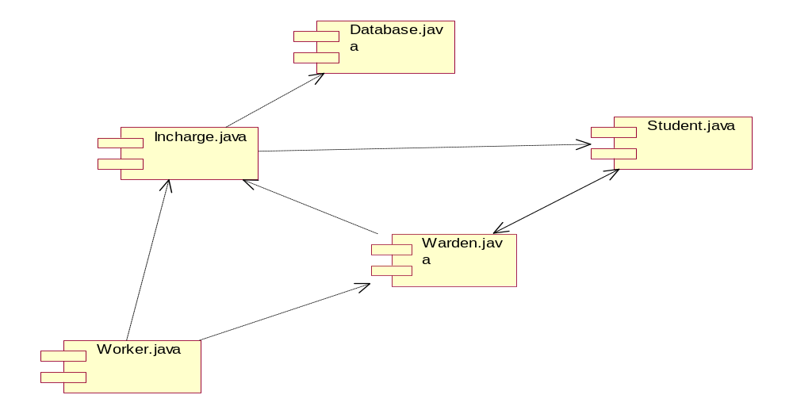

H. DEPLOYMENT DIAGRAM
- A deployment diagram is a diagram that shows the configuration of run time processing nodes and the components that live on them. Graphically, a deployment diagram is a collection of vertices and arcs.
- A deployment diagram shows the configuration of run-time processing nodes and the components that live on them
- Deployment diagrams address the static deployment view of an architecture

Common properties:
A deployment diagram is just a special kind of diagram and shares the same common properties as all other diagrams• a name and graphical contents that are a projection into a model. What distinguishes a deployment diagram from all other kinds of diagrams is its particular content.
Contents:
Deployment diagrams commonly contain
- Nodes
- Dependency and association relationships
Like all other diagrams, deployment diagrams may contain notes and constraints.
Common uses:
1. To model embedded systems
2. To model client/server systems
3. To model fully distributed systems
Deployment Diagram for Hostel management system

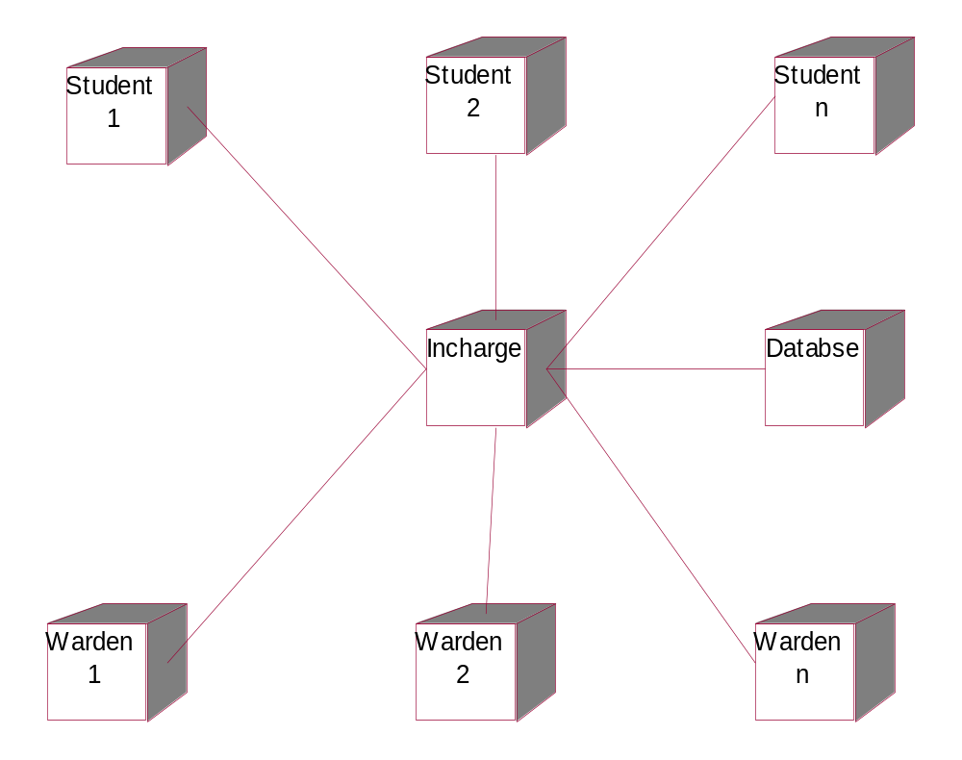

Result: Thus the diagrams (Use Case Diagram, Class Diagram, Sequence Diagram, Collaboration Diagram, State Chart Diagram, Activity Diagram, Component Diagram, and Deployment Diagram) for the Hostel Management System has been designed, executed and output is verified.

Exp.No. 3 | ATM (AUTOMATED TELLER MACHINE) SYSTEM
Dt. | ATM (AUTOMATED TELLER MACHINE) SYSTEM

AIM: Design and develop a UML model for Automated Teller Machine by drawing all the nine uml diagrams.
PROBLEM DEFINITION:
An Automated teller machine (ATM) or automatic banking machine (ABM) is a computerised telecommunications device that provides the clients of a financial institution with access to financial transactions in a public space without the need for a cashier, human clerk or bank teller . On most modern ATMs, the customer is identified by inserting a plastic ATM card with a magnetic stripe or a plastic smart card with a chip, that contains a unique card number and some security information such as an expiration date or CVV(CVV). Authentication is provided by the customer entering a personal identification number (PIN).
ATM is known as Automated Teller Machine which basically deals with transactions between a bank and its account holder.ATM as the name states it is an automatic machine which connects to the bank server to make transactions easily and efficiently
.The important features of ATM are as follows:-
1. An ATM machine can be accessed 24*7 hrs.
2. Whenever an account holder makes transactions using ATM ,all these transactions are reflected back(updated) to his current account.
3. Every account holder who has an ATM card as provided by the bank is given a distinct pass code to access that particular ATM machine.
4. This process works faster than a normal bank transaction which gives a lot of overhead.
5. This kind of transaction is much more secure than the normal transaction.
6. An account holder can access his/her account from any ATM located in the city or state irrespective of the name of the bank.
A. USECASE DIAGRAM
- A use case diagram is a diagram that shows a set of use cases and actors and their relationships.

Contents:

- Use case diagrams commonly contain
    - Use cases
    - Actors
    - Dependency, generalization, and association relationships
- Like all other diagrams, use case diagrams may contain notes and constraints.
- Use case diagrams may also contain packages
- Occasionally, you'll want to place instances of use cases in your diagrams, as well, especially when you want to visualize a specific executing system.
Common uses:
- We apply use case diagrams to model the static use case view of a system. This view primarily supports the behavior of a system
- When you model the static use case view of a system, you'll typically apply use case diagrams in one of two ways.
  - To model the context of a system
  - To model the requirements of a system
Actor:
- An actor represents a coherent set of roles that users of use cases play when interacting with these
use cases.
- Typically, an actor represents a role that a human, a hardware device, or another system plays with a system.
- An instance of an actor, therefore, represents an individual interacting with the system in a specific way
- Actors may be connected to use cases only by association
- An association between an actor and a use case indicates that the actor and the use case communicate with one another, each one possibly sending and receiving messages.
Main flow of events:
The use case starts when the system prompts the Customer for a PIN number. The Customer can now enter a PIN number via the keypad. The Customer commits the entry by pressing the Enter button. The system then checks this PIN number to see if it is valid. If the PIN number is valid, the system acknowledges the entry, thus ending the use case.
Exceptional flow of events:
The Customer can cancel a transaction at any time by pressing the Cancel button, thus restarting the use case. No changes are made to the Customer's account.
Exceptional flow of events:
The Customer can clear a PIN number anytime before committing it and reenter a new PIN number.
Exceptional flow of events:
If the Customer enters an invalid PIN number, the use case restarts. If this happens three times in a row, the system cancels the entire transaction, preventing the Customer from interacting with the ATM for 60 seconds
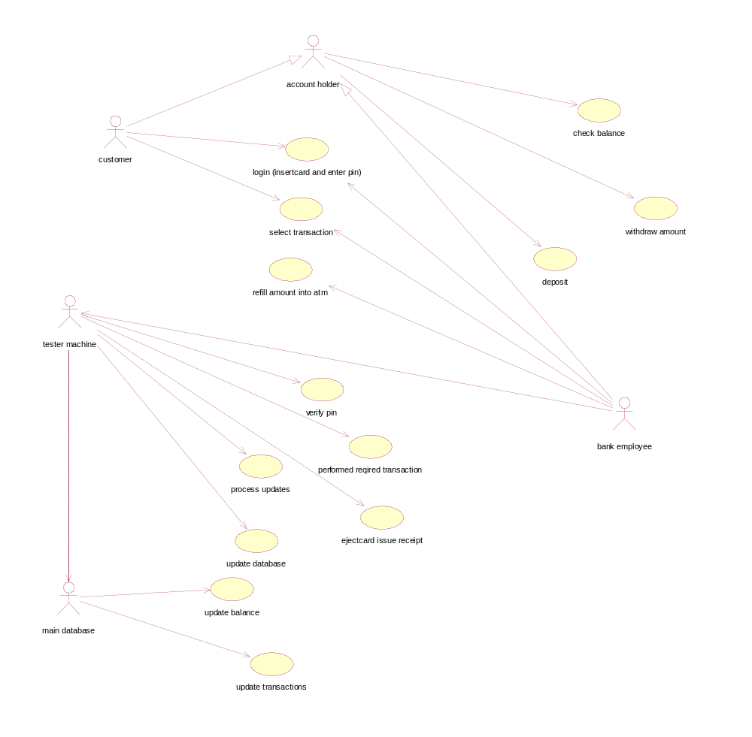

B. CLASS DIAGRAM
- A class diagram shows a set of classes, interfaces, and collaborations and their relationships.
- Graphically, a class diagram is a collection of vertices and arcs.

Contents:
Classes, interfaces, relationships

Common uses:
Modeling the Vocabulary of a System
- Modeling the Distribution of Responsibilities in a System
- Modeling Non software Things
- Modeling Primitive Types

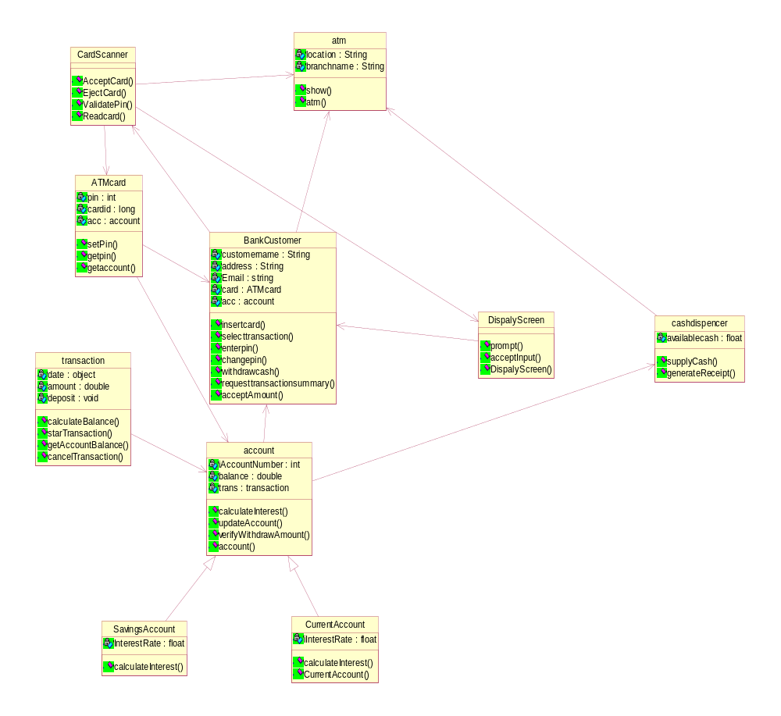

Forward engineering of class diagram:
- Forward engineering is the process of transforming a model into code through a mapping to an implementation language
- Forward engineering results in a loss of information, because models written in the UML are semantically richer than any current object-oriented programming language.
Reverse engineering of class diagram:
- Reverse engineering is the process of transforming code into a model through a mapping from a specific implementation language.
- Reverse engineering results in a flood of information, some of which is at a lower level of detail than you'll need to build useful models.
- Reverse engineering is incomplete. There is a loss of information when forward engineering models into code, and so you can't completely recreate a model from code unless your tools encode information in the source comments that goes beyond the semantics of the implementation language.

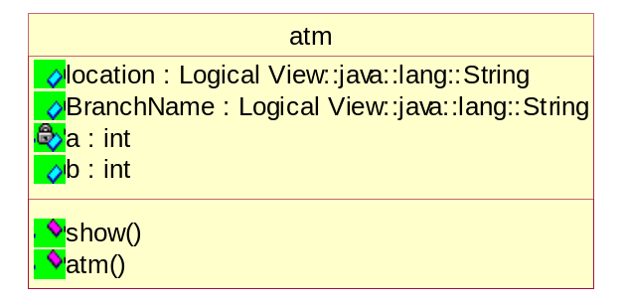
C. SEQUENCE DIAGRAM
- A sequence diagram is an interaction diagram that emphasizes the time-ordering of messages among the objects within a particular context to accomplish particular task
- sequence diagram addresses the dynamic view of a system
Contents:
- Objects, messages and lifelines.
Sequence diagram for login - Main flow:

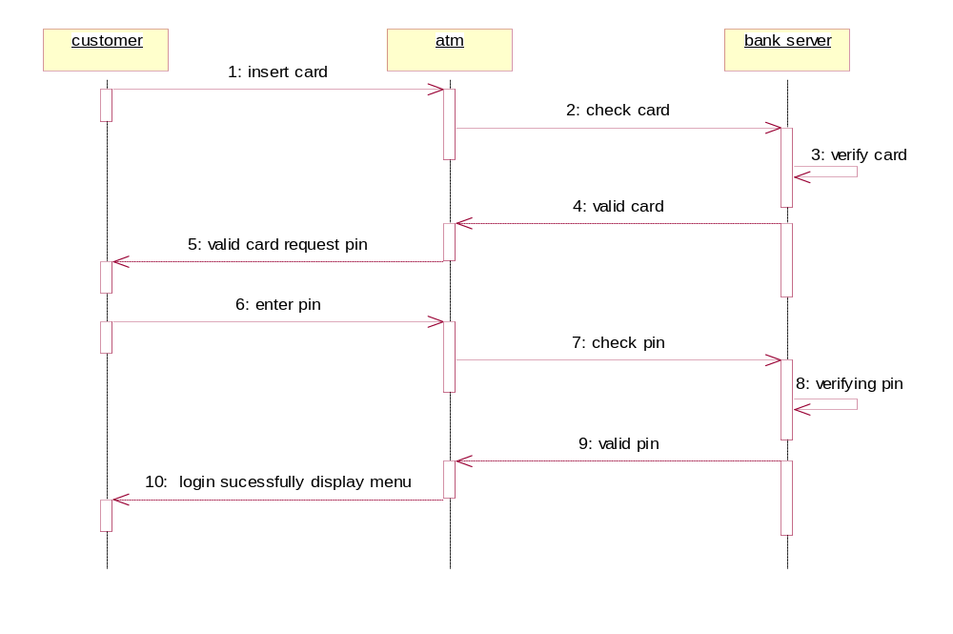

Sequence diagram for withdraw - Main flow:

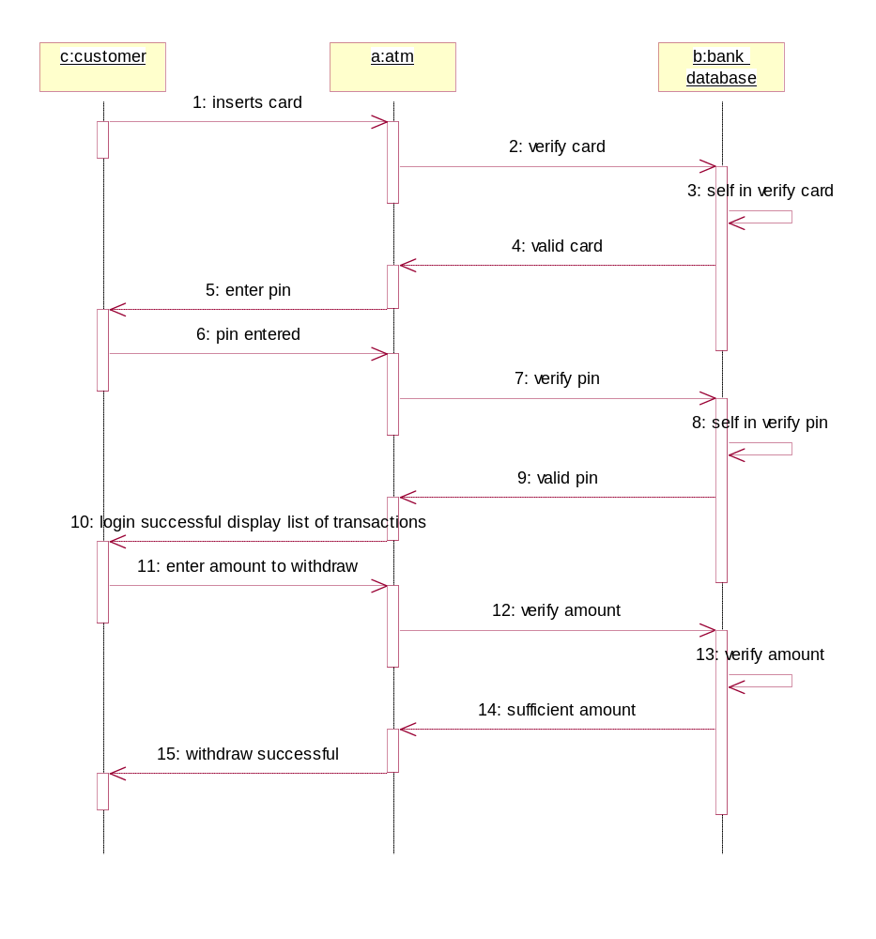

Sequence diagram for login - Alternateflow:

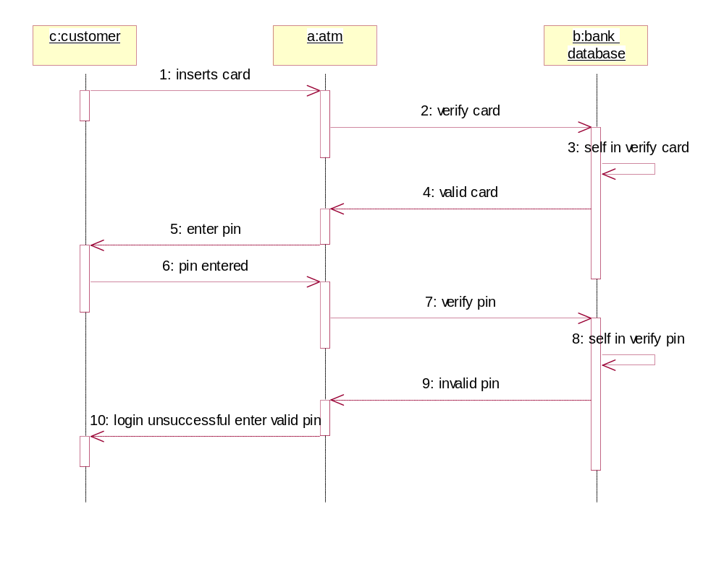

Seuence diagram for login - Alternate flow:

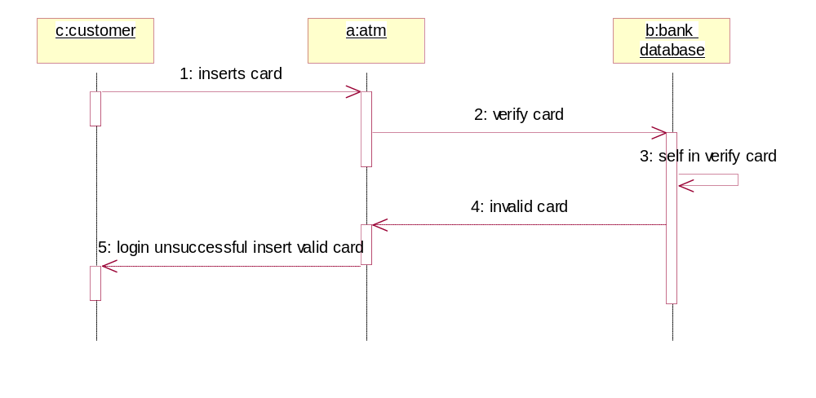

Sequence diagram for withdraw - Alternateflow:

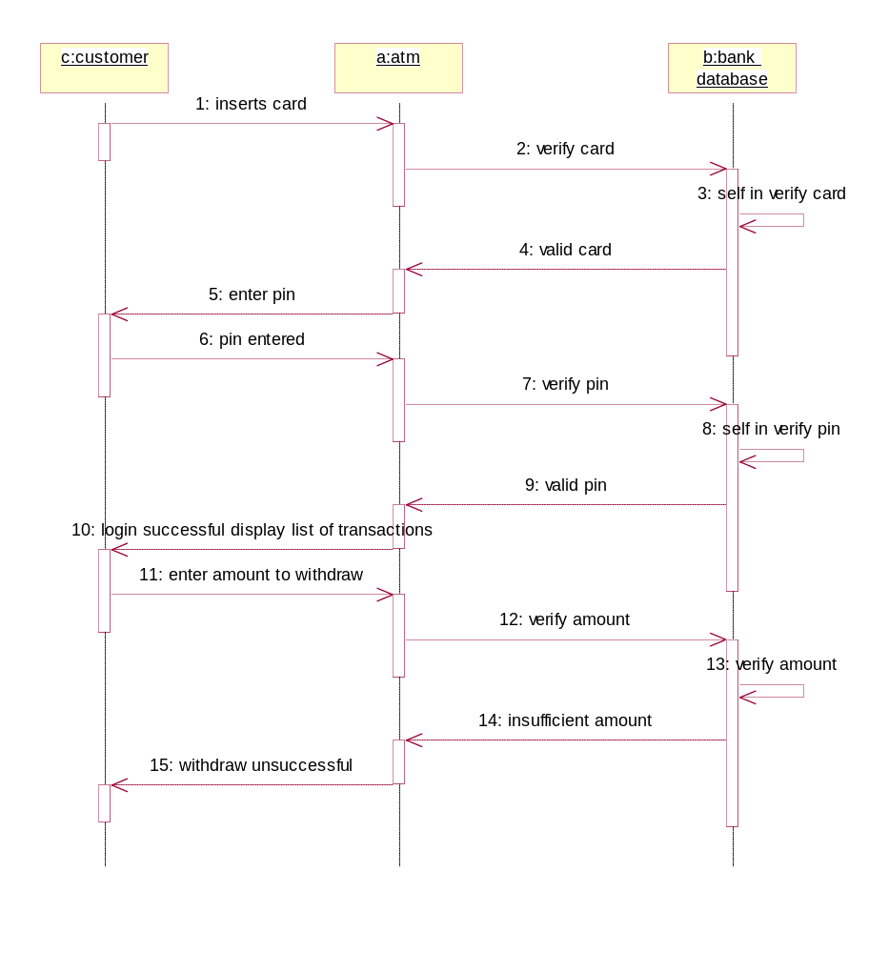

D. COLLABORATION DIAGRAM
Collaboration is a society of classes, interfaces, and other elements that work together to provide some cooperative behavior that's bigger than the sum of all its parts. A collaboration is also the specification of how an element, such as a classifier (including a class, interface, component, node, or use case) or an operation, is realized by a set of classifiers and associations playing specific roles used in a specific way. Graphically, collaboration is rendered as an ellipse with dashed lines.

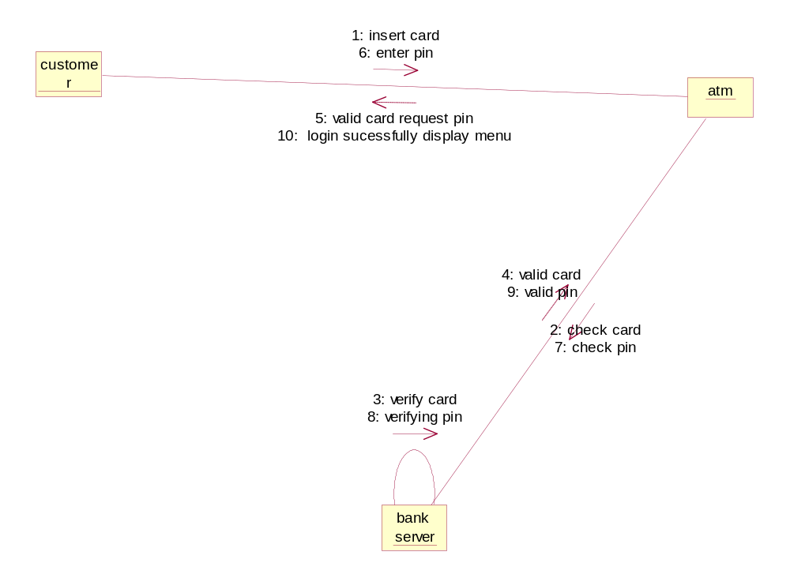
E. STATECHART DIAGRAM
- State diagram s are one of the five diagrams in the UML for modeling the dynamic aspects of system.
- State diagram shows the state machine, emphasizing the flow of control from state to the state.
- State machine is the behavior that specifies the sequence of states an object goes through during of its lifetime in response to those event.

Common Properties:
- A state diagram is just a special diagram and shares the same common properties as do all other diagrams is a name and graphical content that are a projection into a model.
- A state diagram distinguishes the all other diagrams is its contents.

Contents:
State diagrams commonly contain
- Simple states and composite states
- Transitions, events, and actions
Like all other diagram, state diagrams may contain notes and constraints.
Common uses:
State diagrams to model the dynamic aspects of a system, a class, a usecase.
- To model reactive objects
A reactive or event driven object is one whose behavior is best characterized by its response to events dispatched from outside its context. A reactive object is typically idle until it receives event.
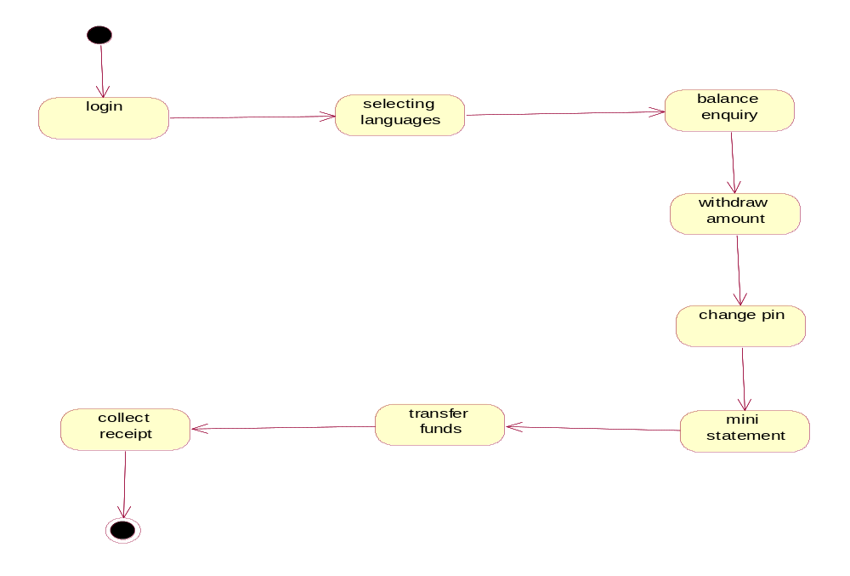

F. ACTIVITY DIAGRAM

- An activity diagram shows the flow from activity to activity. Activity is an ongoing nonatomic execution within a state machine.
- Activities ultimately result in some action, which is made up of executable atomic computations that result in a change in state of the system or the return of a value.
- Actions encompass calling another operation, sending a signal, creating or destroying an object, or some pure computation, such as evaluating an expression.
- Graphically, an activity diagram is a collection of vertices and arcs.

Contents

- Activity diagrams commonly contain
  - Activity states and action states
  - Transitions
  - Objects
- Like all other diagrams, activity diagrams may contain notes and constraints.

Common Uses:

- We use activity diagrams to model the dynamic aspects of a system
- These dynamic aspects may involve the activity of any kind of abstraction in any view of a system's architecture, including classes, interfaces, components, and nodes.
- When you model the dynamic aspects of a system, we'll typically use activity diagrams in two ways.
    - To model a workflow
    - To model an operation

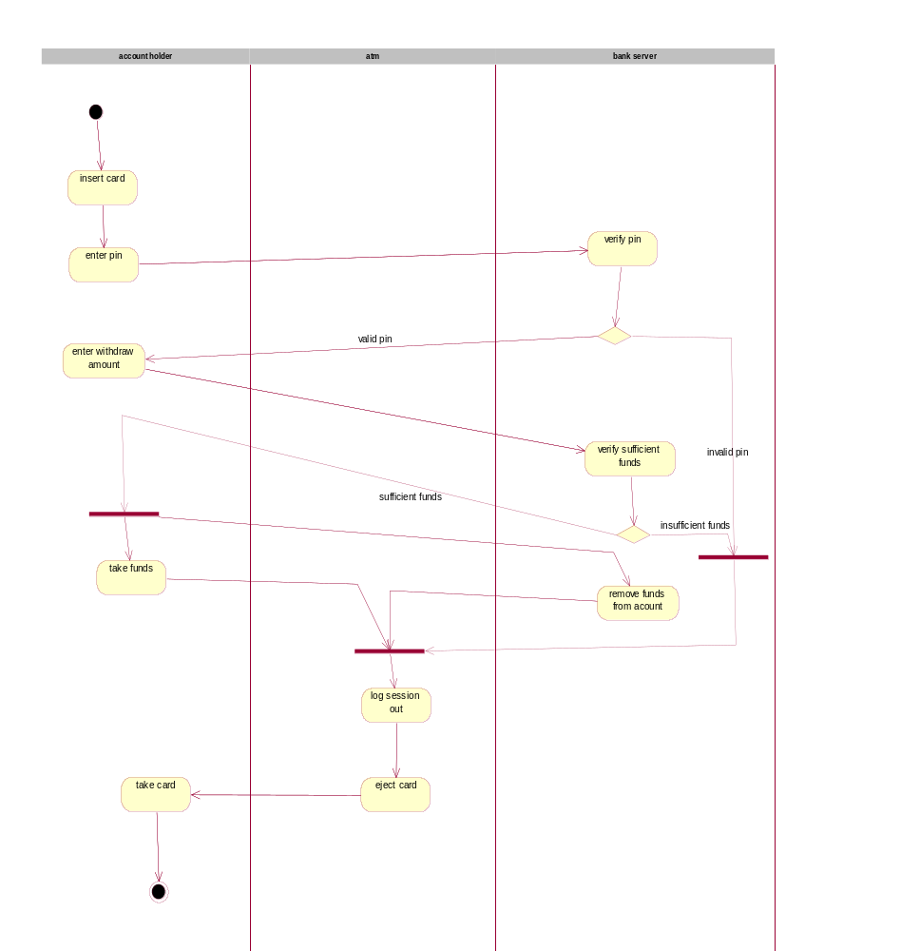

G. COMPONENT DIAGRAM
A component diagram shows a set of components and their relationships. Graphically, a component diagram is a collection of vertices and arcs.
Contents:
Component diagrams commonly contain
- Components
- Interfaces

- Dependency, generalization, association, and realization relationships Like all other diagrams, component diagrams may contain notes and constraints.

Component diagrams may also contain packages or subsystems, both of which are used to group elements of your model into larger chunks. Sometimes, you'll want to place instances in your component diagrams, as well, especially when you want to visualize one instance of a family of component-based systems.
Common Uses:
1. To model source code
2. To model executable releases
3. To model physical databases
4. To model adaptable systems
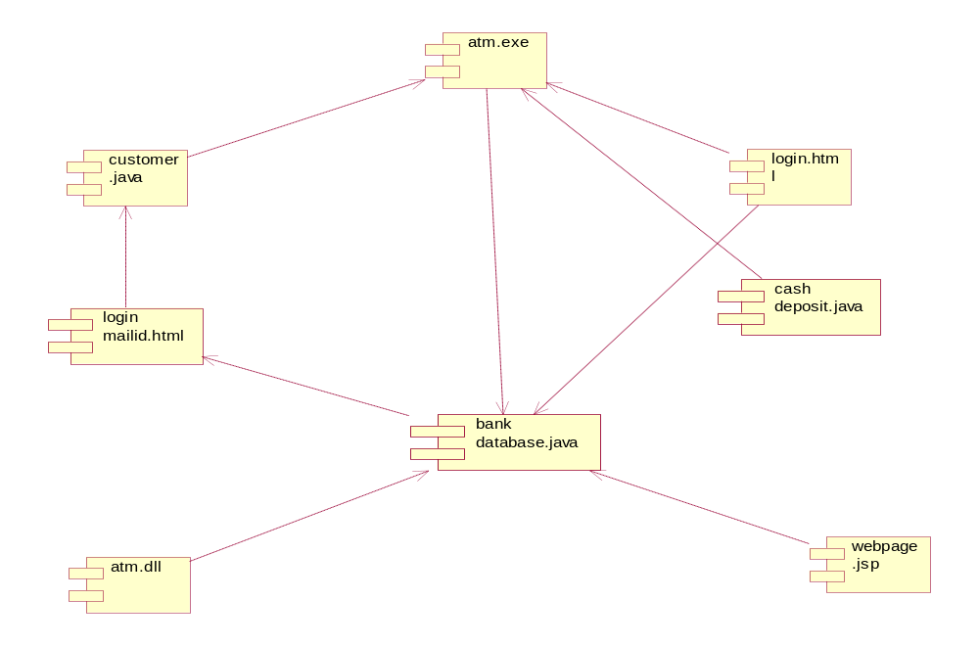

H. DEPLOYMENT DIAGRAM
A node is a physical element that exists at run time and represents a computational resource, generally having at least some memory and, often, processing capability. Graphically, a node is rendered as a cube.
Common Properties:
A deployment diagram is just a special kind of diagram and shares the same common properties as all other diagrams• a name and graphical contents that are a projection into a model. What distinguishes a deployment diagram from all other kinds of diagrams is its particular content.
Contents:
Deployment diagrams commonly contain
- Nodes
- Dependency and association relationships

Common Uses:
1. To model embedded systems
2. To model client/server systems
3. To model fully distributed systems
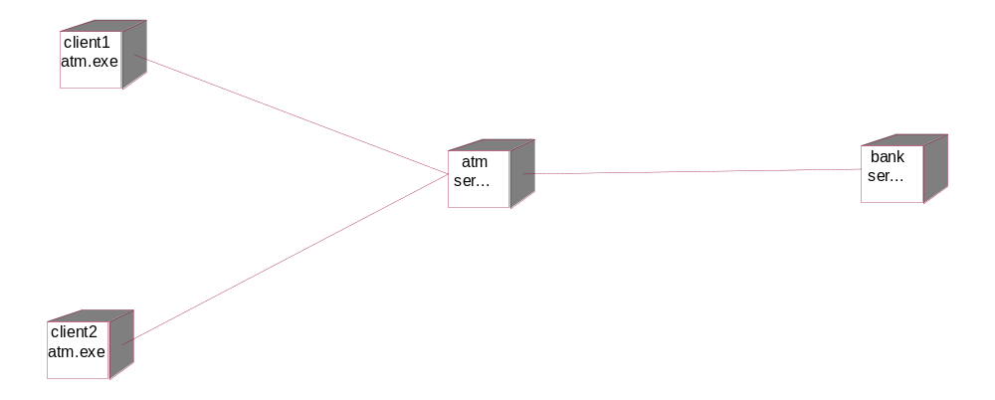Result: Thus the diagrams (Use Case Diagram, Class Diagram, Sequence Diagram, Collaboration Diagram, State Chart Diagram, Activity Diagram, Component Diagram, and Deployment Diagram) for the ATM (Automated Teller Machine) System have been designed, executed and output is verified
Exp.No. 4 | LIBRARY MANAGEMENT SYSTEM
Dt. | LIBRARY MANAGEMENT SYSTEM

AIM: To Develop UML Diagrams for Library Management System.
PROBLEM DEFINITION:

The Library Management System is library management software for the purpose of monitoring and controlling the transactions in a library. The library management system gives us the complete information about the library and the daily transactions done in a Library. We need to maintain the record of new s and retrieve the details of books available in the library which mainly focuses on basic operations in a library like adding new member, new books, and up new information, searching books and members and facility to borrowed return books. It features a familiar and well thought-out, an attractive user interface, combined with strong searching, insertion and reporting capabilities. The report generation facility of library system helps to get a good idea of which are the borrowed by the members, makes users possible to generate hard copy.
The following are the brief description on the functions achieved through End-Users:
•Librarian: To maintain and update the records and also to cater the needs of the users.
•Reader: Need books to read and also places various requests to the librarian.
•Vendor: To provide and meet the requirement of the prescribed books.

A. USECASE DIAGRAM

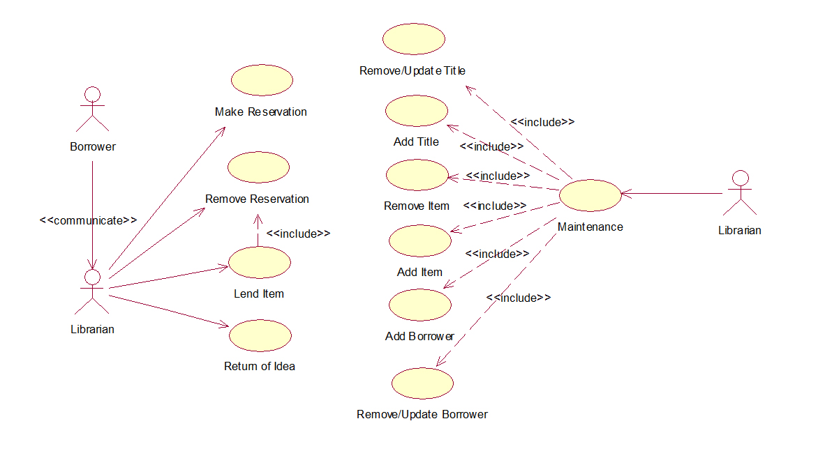

B. CLASS DIAGRAM
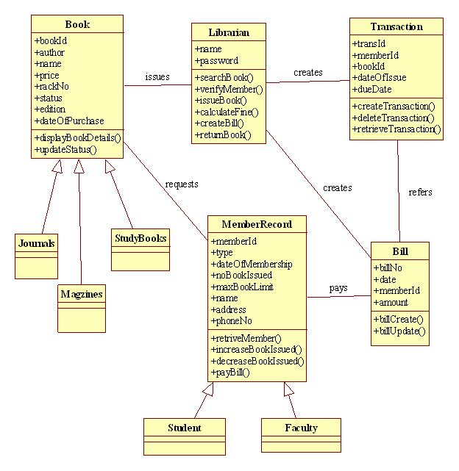

C. SEQUENCE DIAGRAM
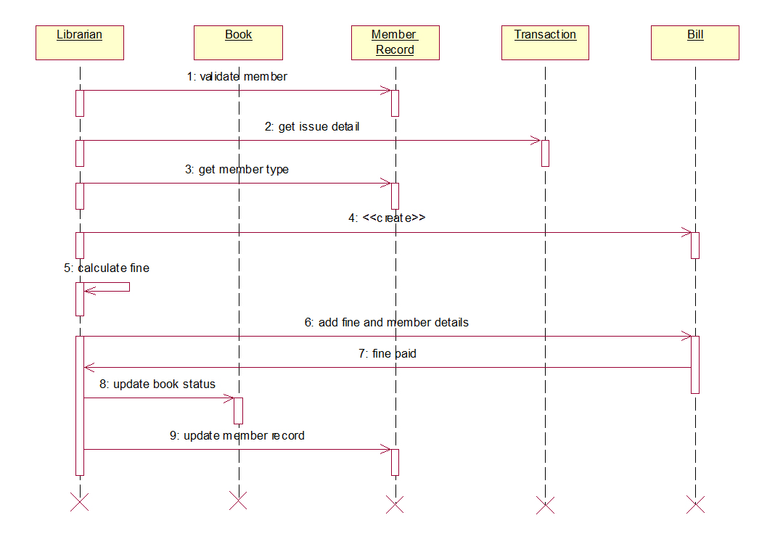

D. COLLABORATION DIAGRAM
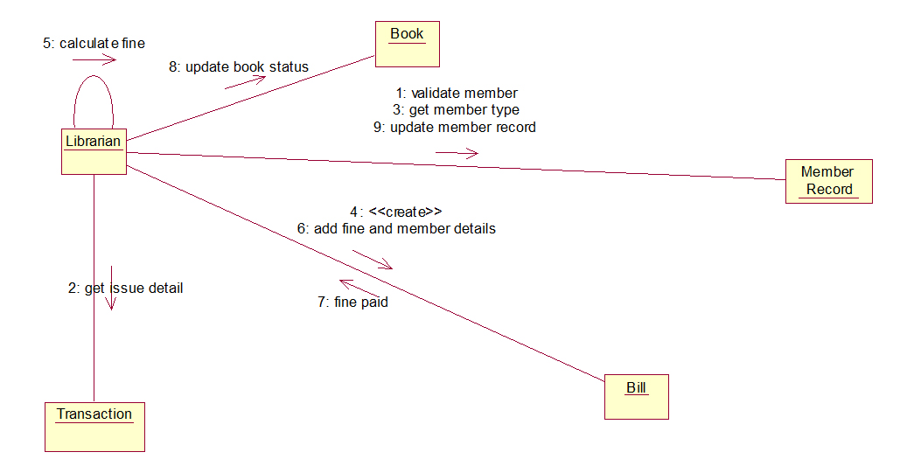

E. STATECHART DIAGRAM
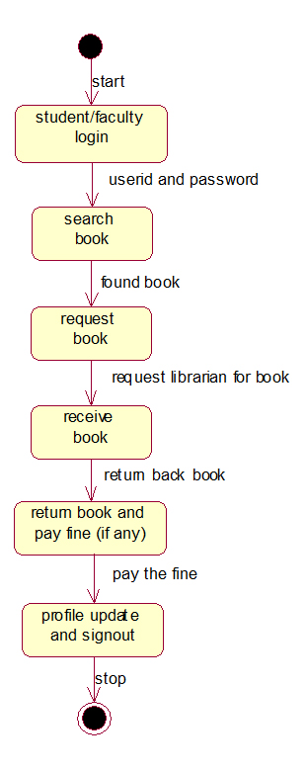

F. ACTIVITY DIAGRAM

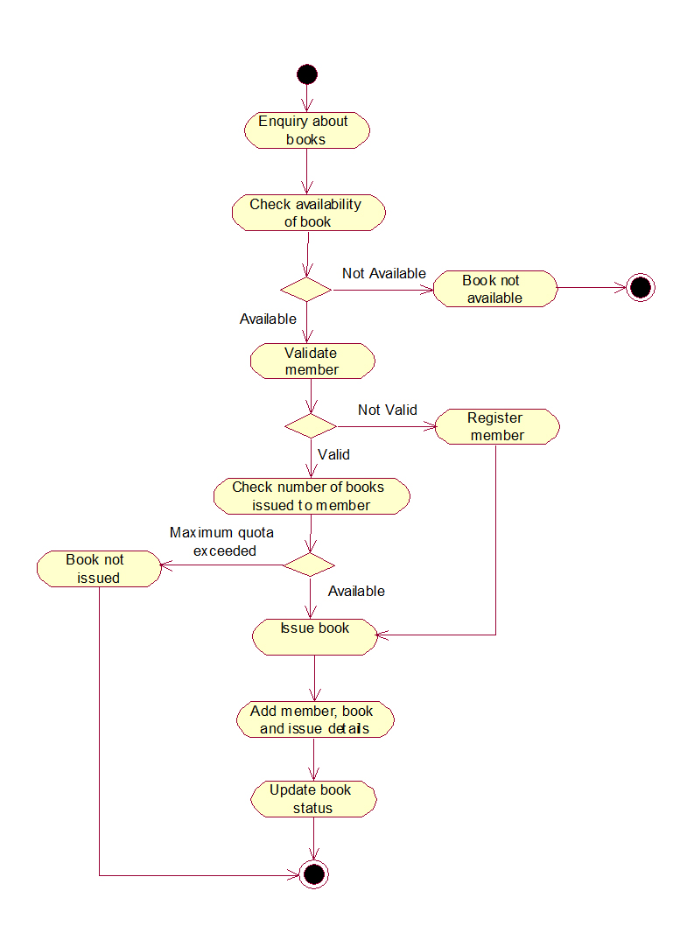

G. COMPONENT DIAGRAM
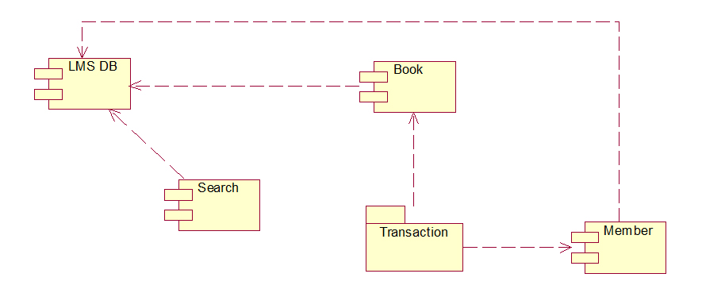

H. DEPLOYMENT DIAGRAM
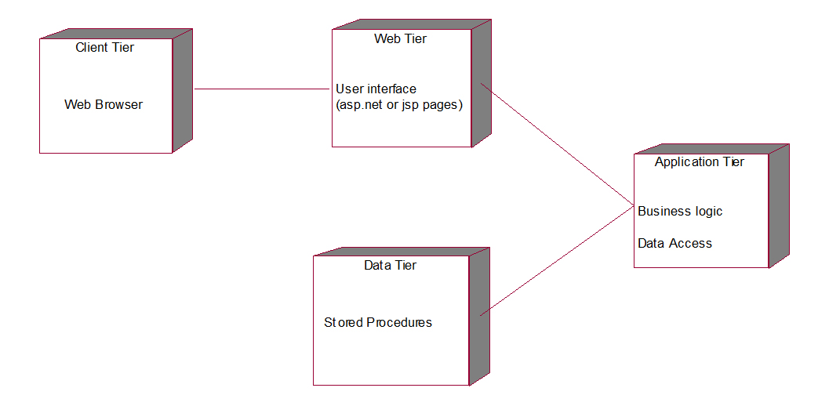

Result: Thus the diagrams (Use Case Diagram, Class Diagram, Sequence Diagram, Collaboration Diagram, State Chart Diagram, Activity Diagram, Component Diagram, and Deployment Diagram) for the Library Management System has been designed, executed and output is verified.

Exp.No. 5 | ONLINE BANKING SYSTEM
Dt. | ONLINE BANKING SYSTEM

AIM: To Develop UML Diagrams for College Information System.
PROBLEM DEFINITION:

This banking process consists of some divisions. There are customer details, creating a new account, withdrawing money, loan details and depositing money. The customer details consist of customer name, address, phone number, account number.
To create a new account verifies the rules. Enter the account and
then get an account number from a database. To withdraw money checks the balance in our account and then get the money. The loan details consist of loan types like home loans, car loans, education loans etc.
To deposit money enter the account number and give the account to be deposited.

A. USECASE DIAGRAM
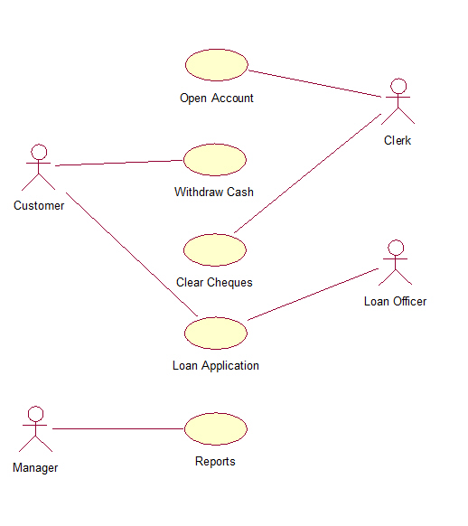

B. CLASS DIAGRAM
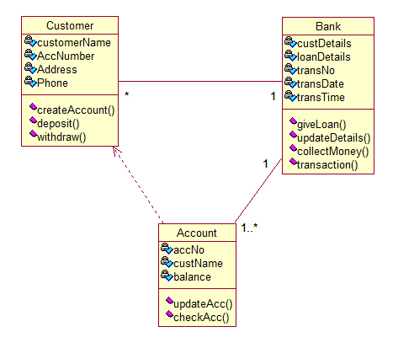

C. SEQUENCE DIAGRAM
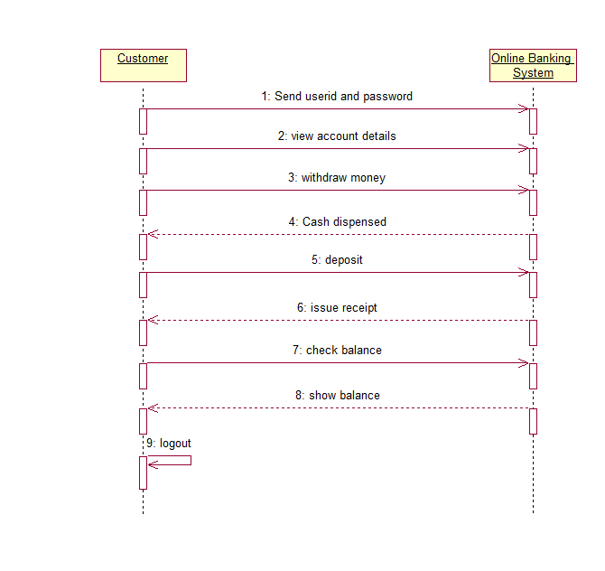

D. COLLABORATION DIAGRAM
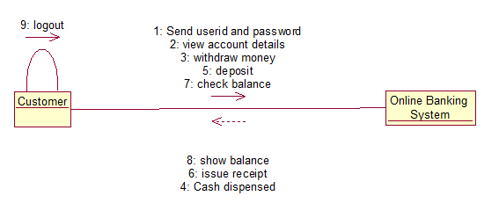

E. STATECHART DIAGRAM
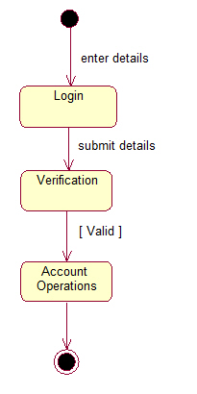

F. ACTIVITY DIAGRAM
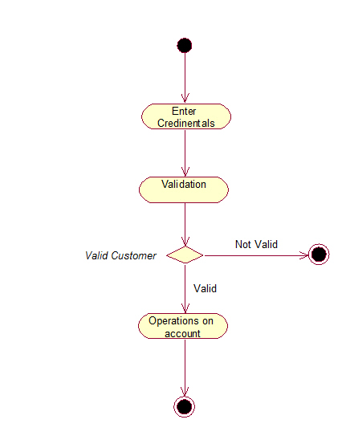

G. COMPONENT DIAGRAM
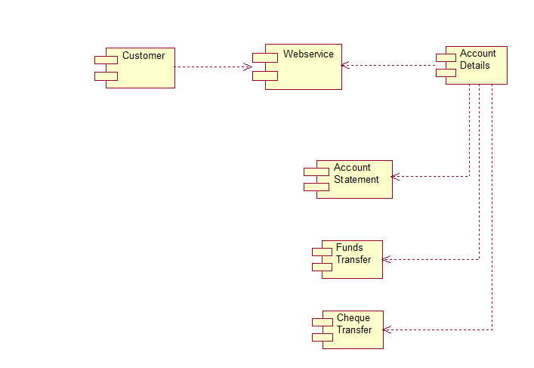

H. DEPLOYMENT DIAGRAM
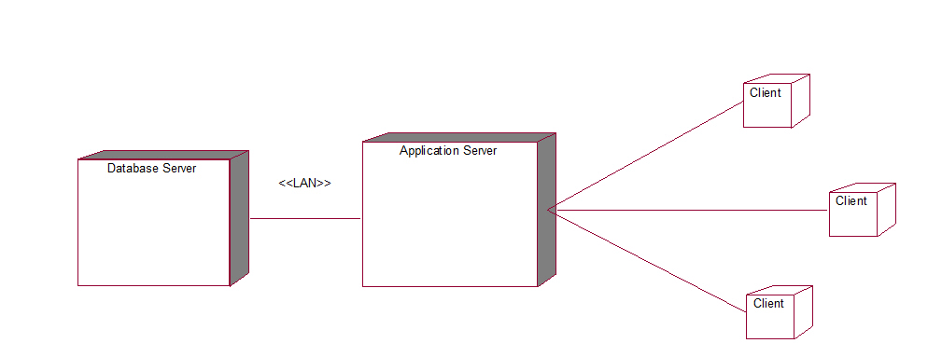

Result: Thus the diagrams (Use Case Diagram, Class Diagram, Sequence Diagram, Collaboration Diagram, State Chart Diagram, Activity Diagram, Component Diagram, and Deployment Diagram) for the Online Banking System has been designed, executed and output is verified.

SOFTWARE TESTING LAB

Exp.No. 1 | PROGRAM FOR CONTROL STATEMENTS
Dt. | PROGRAM FOR CONTROL STATEMENTS

AIM: Write programs in C Language to demonstrate the working of the following constructs:
i) do...while ii) while….do iii) if…else iv) switch v) for

PROGRAM:
#include<string.h>
#include<conio.h>
#include<stdlib.h>
#include<stdio.h>
main()
{
int ch,a,b,c,i=0,sum=0,n;
char s[100];
clrscr();
printf("1.dowhile\n 2.while\n 3.for\n 4.if-else\n");
printf("Enter your choice\n");
scanf("%d", &ch);
switch(ch)
{
case 1: printf("executing dowhile loop\n");
a=0; b=1;
printf("for generating fibbonacciseries\n");
printf("enter value for n\n");
scanf("%d",&n);
do
{
c=a+b;
printf("%d\t",c);
a=b;
b=c;
i++;
} while(i<n);
break;
case 2: printf("executing while loop for reversing a number\n");
printf("enter a number\n");
scanf("%s",s) ;
i=0;c=0;b=0;
a=strlen(s)-1;
while((s[i]!='\0')&&(a!=i))
{
if(s[i]=='0')
{
c++;
i++;
}
if(s[a]=='0')
{
b++;
a--;
}
if(s[i]!='0'&&s[a]!='0')
break;
}
n=atoi(s);
while(n>0)
{
a=n%10;
sum=(sum*10)+a;
n=n/10;
}
while(c>0)
{
sum*=10;
c--;
}
printf("after reversing the number is:");
while(b>0)
{
printf("%d",c);
b--;
}
printf("%d\n",sum);
break;
case 3: printf("executing for loop to find factorial a number\n");
printf("enter a number\n");
scanf("%d", &n);
i=0; a=n;
for(sum=1;n>0;n--)
{
sum=sum*n;
}
printf("%d factorial is: %d\n",a,sum);
break;
case 4: printf("executing if-else stmt to find a number is even or odd number \n");
printf("enter a number\n");
scanf("%d", &n);
if(n%2==0)
printf("even number\n");
else
printf("odd number\n");
break;
default:
exit(0);
}
printf("\n end of main function\n");
getch();
}

Output:
1)
1.dowhile
2.while
3.for
4.if-else
Enter your choice
1
executing dowhile loop
for generating fibbonacciseries
enter value for n
6
1 2 3 5 8 13
end of main function

2)
1.dowhile
2.while
3.for
4.if-else
Enter your choice
2
executing while loop for reversing a number
enter a number
1002
after reversing the number is:2001
end of main function

3)
1.dowhile
2.while
3.for
4.if-else
Enter your choice
2
executing while loop for reversing a number
enter a number
0023
after reversing the number is:3200
end of main function

4)
1.dowhile
2.while
3.for
4.if-else
Enter your choice
2
executing while loop for reversing a number
enter a number
5600
after reversing the number is:0065
end of main function

5)
1.dowhile
2.while
3.for
4.if-else
Enter your choice
3
executing for loop to find factorial a number
enter a number
6
6 factorial is: 720
end of main function

6)
1.dowhile
2.while
3.for
4.if-else
Enter your choice
4
executing if-else stmt to find a number is even or odd number
enter a number
23
odd number
end of main function

Result: Thus the Program For Control Statements has been excucuted and tested successfully.

Exp.No. 2 | MATRIX MULTIPLICATION
Dt. | MATRIX MULTIPLICATION

AIM: A program written in C language for Matrix Multiplication fails Introspect the causes for its failure and write down the possible reasons for its failure

PROGRAM:

#include<stdio.h>
#include<conio.h>
main()
{
int a[5][5],b[5][5],c[10][10],m,n,p,q,i,j,k;
clrscr();
printf("Enter order for matrix A\n");
scanf("%d %d",&m,&n);
printf("Enter order for matrix B\n");
scanf("%d %d",&p,&q);
if(n==p)
{
printf("Matrix multiplication possible\n");
printf("Enter values for A Matrix\n");
for(i=0;i<m;i++)
{
for(j=0;j<n;j++)
{
scanf("%d",&a[i][j]);
}
}
printf("Matrix A values are\n");
for(i=0;i<m;i++)
{
for(j=0;j<n;j++)
{
printf("%4d ",a[i][j]);
}
printf("\n");
}
printf("enter values for B Matrix\n");
for(i=0;i<p;i++)
{
for(j=0;j<q;j++)
{
scanf("%d",&b[i][j]);
}
}
printf("B Matrix values are\n");
for(i=0;i<p;i++)
{
for(j=0;j<q;j++)
{
printf("%4d",b[i][j]);
}
printf("\n");
}
printf("Matrix multiplication\n");
for(i=0;i<m;i++)
{
for(j=0;j<q;j++)
{
c[i][j]=0;
for(k=0;k<n;k++)
{
c[i][j]=c[i][j]+a[i][k]*b[k][j];
}
}
}
printf("Result is:\n");
for(i=0;i<m;i++)
{
for(j=0;j<q;j++)
{
printf("%4d",c[i][j]);
}
printf("\n");
}
} else
{ printf("Matrix Multiplication is not possible"); }
getch(); }

Ouput:
1)
Enter order for matrix A
2
3
Enter order for matrix B
2
2
Matrix Multiplication is not possible
2)
Enter order for matrix A
2
2
Enter order for matrix B
2
2
Matrix multiplication possible
Enter values for A Matrix
1
2
c
Matrix A values are
1 2
1805 27099
enter values for B Matrix
B Matrix values are
0 0
0 0
Matrix multiplication
Result is:
0 0
0 0
3)
Enter order for matrix A
2
2
Enter order for matrix B
2
2
Matrix multiplication possible
Enter values for A Matrix
1
2
3
4
Matrix A values are
1 2
3 4
enter values for B Matrix
1
3
t
B Matrix values are
1 3
0 0
Matrix multiplication
Result is:
1 3
3 9
4)
Enter order for matrix A
2
x
Enter order for matrix B
Matrix Multiplication is not possible

5)
Enter order for matrix A
t
Enter order for matrix B
Matrix Multiplication is not possible
6)
Enter order for matrix A
2
2
Enter order for matrix B
p
Matrix Multiplication is not possible
7)
Enter order for matrix A
2
2
Enter order for matrix B
2
3
Matrix multiplication possible
Enter values for A Matrix
1
2
3
4
Matrix A values are
1 2
3 4
enter values for B Matrix
3.
B Matrix values are
3 1 1
1 1 1 Matrix multiplication
Result is: 5 3 3
13 7 7
8)
Enter order for matrix A
2
2
Enter order for matrix B
2
2
Matrix multiplication possible
Enter values for A Matrix
60000
35000
2
900
Matrix A values are
-5536 -30536
2 900
enter values for B Matrix
2
1
1
1
B Matrix values are
2 1
1 1
Matrix multiplication
Result is:
2392829464
904 902

Result: Thus the Program for Matrix Multiplication has been excucuted and tested successfully.

Exp.No. 3 | SYSTEM SPECIFICATION AND REPORT IN ATM SYSTEM
Dt. | SYSTEM SPECIFICATION AND REPORT IN ATM SYSTEM

AIM: Take any system (e.g. ATM system) and study its system specifications and report the various bugs

DESCRIPTION:
Features to be tested:
- Validity of the card.
- Withdraw Transaction flow of ATM.
- Authentication of the user’s.
- Dispense the cash from the account.
- Verify the balance enquiry.
- Change of PIN number.

BUG ID BUG NAME
ATM_001 | Invalid Card
ATM_002 | Invalid PIN
ATM_003 | Invalid Account type
ATM_004 | Insufficient Balance
ATM_005 | Transaction Limit
ATM_006 | Day limit
ATM_007 | Invalid money denominations
ATM_008 | Receipt not printed
ATM_009 | PIN change mismatch

Bug Report:
Bug Id: ATM_001
Bug Description: Invalid card
Steps to reproduce:
1. Keep valid card in the ATM.
Expected Result: Welcome Screen
Actual Result: Invalid card
Status : Pass/Fail

Bug Id: ATM_002
Bug Description: Invalid PIN entered
Steps to reproduce:
- Keep a valid card in ATM.
- Enter the authorized PIN.
- Menu screen should be displayed.
Expected Result: Menu screen displayed
Actual Result: Invalid PIN screen is displayed
Status : Pass/Fail

Bug Id: ATM_003
Bug Description: Invalid Account type selected.
Steps to reproduce:
- Enter a valid user PIN number.
- Select the withdraw option on the main menu.
- Choose the correct type of account (either savings or current account).
Expected Result: Enter the Amount screen displayed
Actual Result: Invalid Account type screen is displayed.
Status : Pass/Fail

Bug Id: ATM_004
Bug Description: Insufficient Balance
Steps to reproduce:
- Menu screen should be displayed.
- Select the withdraw option.
- Select the correct type of account.
- Enter the sufficient amount to withdraw from the account.
- Dispense the cash screen & amount to be deducted from account
Expected Result: Collect the amount screen displayed
Actual Result: Insufficient balance in the account
Status : Pass/Fail

Bug Id: ATM_005
Bug Description: Withdraw Limit per transaction.
Steps to reproduce:
- Menu screen should be displayed.
- Select the withdraw option.
- Select the correct type of account.
- Enter sufficient amount to withdraw from the account Transaction within the limit.
- Dispense the cash screen & amount to be deducted from account.
Expected Result: Cash is dispensed and collect the receipt
Actual Result: Transaction limit exceeded screen is displayed
Status : Pass/Fail

Bug Id: ATM_006
Bug Description: Withdraw limit per day
Steps to reproduce:
- Keep a valid card in ATM.
- Enter the authorized PIN.
- Enter the amount to withdraw from the account.
- Amount enter is over the day limit (>40000)
- Amount enter is over the day limit and display screen is displayed.
Expected Result: Cash is dispensed and collect the receipt.
Actual Result: Day limit exceeded screen is displayed.
Status : Pass/Fail

Bug Id: ATM_007
Bug Description: Amount enter denominations
Steps to reproduce:
- Keep a valid card in ATM.
- Enter the authorized PIN.
- Enter the amount which should be in multiples of 100.
- Cash Dispenser screen is displayed.
Expected Result: Collect the amount screen is displayed.
Actual Result: Amount enter not in required denominations.
Status : Pass/Fail

Bug Id: ATM_008
Bug Description: Statement not printed
Steps to reproduce:
1. Keep a valid card in ATM.
2.Enter the authorized PIN.
3.Select the mini statement.
4.Current balance is displayed on the screen.
5.Collect printed receipt of the statement.
Expected Result: Collect the mini statement receipt
Actual Result: receipt not printed.
Status : Pass/Fail

Bug Id: ATM_009
Bug Description: PIN mismatch
Steps to reproduce:
- Keep a valid card in ATM.
- Enter the authorized PIN.
- Select the change PIN option on the menu.
- Enter the current PIN.
- Enter the new PIN.
- Retype the new PIN
- PIN successfully changed displayed on the screen.
Expected Result: PIN change successful.
Actual Result: PIN mismatched due to wrong PIN entered
Status : Pass/Fail

Result: Thus ATM system and its specifications is successfully studied and reported the various bugs.

Exp.No. 4 | CREATING A TEST CASE
Dt. | CREATING A TEST CASE

AIM: Write the test cases for any known application (e.g. banking application)
DESCRIPTION:
- Checking mandatory input parameters
- Checking optional input parameters
- Check whether able to create account entity.
- Check whether you are able to deposit an amount in the newly created account (and thus updating the balance)
- Check whether you are able to withdraw an amount in the newly created account (after deposit) (and thus updating the balance)
- Check whether company name and its pan number and other details are provided in case of salary account
- Check whether primary account number is provided in case of secondary account
- Check whether company details are provided in cases of company's current account
- Check whether proofs for joint account is provided in case of joint account
- Check whether you are able deposit an account in the name of either of the person in an joint account.
- Check whether you are able withdraws an account in the name of either of the person in an joint account.
- Check whether you are able to maintain zero balance in salary account
- Check whether you are not able to maintain zero balance (or mini balance) in non-salary account.
Result: Thus the test cases for banking application are successfully written.

Exp.No. 5 | CREATING A TEST PLAN
Dt. | CREATING A TEST PLAN

AIM: Create a test plan document for any application (e.g. Library Management System)
DESCRIPTION:
The Library Management System is an online application for assisting a librarian managing book library in a University. The system would provide basic set of features to add/update clients, add/update books, search for books, and manage check-in / checkout processes. Our test group tested the system based on the requirement specification. This test report is the result for testing in the LMS. It mainly focuses on two problems

What we will test
- How we will test.
- GUI test
Pass criteria: librarians could use this GUI to interface with the backend library database without any difficulties

Database test
Pass criteria: Results of all basic and advanced operations are normal (refer to section 4)

Basic function test Add a student
Each customer/student should have following attributes: Student ID/SSN (unique), Name, Address and Phone number.
The retrieved customer information by viewing customer detail should contain the four attributes.

Update/delete student
- The record would be selected using the student ID.
- Updates can be made on full. Items only: Name, Address, Phone number The record can be deleted if there are no books issued by user. The updated values would be reflected if the same customer's ID/SSN is called for.

7. Check-in book
Librarians can check in a book using its call number
- The check-in can be initiated from a previous search operation where user has selected a setof books.
- The return date would automatically reflect the current system date.
- Any late fees would be computed as difference between due date and return date at rate of 10 cents a day.

Result: Thus the test plan document for Library Management is successfully created.

Exp.No. 6 | WIN RUNNER
Dt. | WIN RUNNER

AIM: Study of Win Runner Testing Tool and its implementation
DESCRIPTION:
Study of Any Testing Tool( Win Runner)
Win Runner is a program that is responsible for the automated testing of software. Win Runner is a Mercury Interactive enterprise functional testing tool for Microsoft windows applications.
Importance of Automated Testing:
- Reduced testing time
- Consistent test procedures – ensure process repeatability and resource independence. Eliminates errors of manual testing
- Reduces QA cost – Upfront cost of automated testing is easily recovered over the lifetime of the product
- Improved testing productivity – test suites can be run earlier and more often
- Proof of adequate testing
- For doing Tedious work – test team members can focus on quality areas.
Win Runner Uses:
- With Win Runner sophisticated automated tests can be created and run on an application.
- A series of wizards will be provided to the user, and these wizards can create tests in an automated manner.
- Another impressive aspect of Win Runner is the ability to record various interactions, and transform them into scripts. Win Runner is designed for testing graphical user interfaces.
- When the user makes an interaction with the GUI, this interaction can be recorded. Recording the interactions allows to determine various bugs that need to be fixed.
- When the test is completed, Win Runner will provide with detailed information regarding the results. It will show the errors that were found, and it will also give important information about them. The good news about these tests is that they can be reused many times.
- Win Runner will test the computer program in a way that is very similar to normal user interactions. This is important, because it ensures a high level of accuracy and realism. Even if an engineer is not physically present, the Recover manager will troubleshoot any problems that may occur, and this will allow the tests to be completed without errors.
- The Recover Manager is a powerful tool that can assist users with various scenarios. This is important, especially when important data needs to be recovered.
The goal of Win Runner is to make sure business processes are properly carried out. Win Runner uses TSL, or Test Script Language.

Win Runner Testing Modes
Context Sensitive
Context Sensitive mode records your actions on the application being tested in terms of the GUI objects you select (such as windows, lists, and buttons), while ignoring the physical location of the object on the screen. Every time you perform an operation on the application being tested, a TSL statement describing the object selected and the action performed is generated in the test script. As you record, Win Runner writes a unique description of each selected object to a GUI map.
The GUI map consists of files maintained separately from your test scripts. If the user interface of your application changes, you have to update only the GUI map, instead of hundreds of tests. This allows you to easily reuse your Context Sensitive test scripts on future versions of your application.
To run a test, you simply play back the test script. Win Runner emulates a user by moving the mouse pointer over your application, selecting objects, and entering keyboard input. Win Runner reads the object descriptions in the GUI map and then searches in the application being tested for objects matching these descriptions. It can locate objects in a window even if their placement has changed.
Analog
Analog mode records mouse clicks, keyboard input, and the exact x- and y-coordinates traveled by the mouse. When the test is run, Win Runner retraces the mouse tracks. Use Analog mode when exact mouse coordinates are important to your test, such as when testing a drawing application.
The Win Runner Testing Process
Testing with Win Runner involves six main stages:
1. Create the GUI Map
The first stage is to create the GUI map so Win Runner can recognize the GUI objects in the application being tested. Use the Rapid Test Script wizard to review the user interface of your application and systematically add descriptions of every GUI object to the GUI map. Alternatively, you can add descriptions of individual objects to the GUI map by clicking objects while recording a test.
2. Create Tests
Next is creation of test scripts by recording, programming, or a combination
of both. While recording tests, insert checkpoints where we want to check the response of the application being tested. We can insert checkpoints that check GUI objects, bitmaps, and databases. During this process, Win Runner captures data and saves it as expected results—the expected response of the application being tested.
3. Debug Tests
Run tests in Debug mode to make sure they run smoothly. One can set breakpoints, monitor variables, and control how tests are run to identify and isolate defects. Test results are saved in the debug folder, which can be discarded once debugging is finished.
When Win Runner runs a test, it checks each script line for basic syntax errors, like incorrect syntax or missing elements in If, While, Switch, and For statements. We can use the Syntax Check options (Tools >Syntax Check) to check for these types of syntax errors before running your test.
4. Run Tests
Tests can be run in Verify mode to test the application. Each time Win Runner
encounters a checkpoint in the test script, it compares the current data of the application being tested to the expected data captured earlier. If any mismatches are found, Win Runner captures them as actual results.
5. View Results
Following each test run, Win Runner displays the results in a report. The report details all the major events that occurred during the run, such as checkpoints, error messages, system messages, or user messages.
If mismatches are detected at checkpoints during the test run, we can view the expected results and the actual results from the Test Results window. In cases of bitmap mismatches, one can also view a bitmap that displays only the difference between the expected and actual results.
We can view results in the standard Win Runner report view or in the Unified report view. The Win Runner report view displays the test results in a Windows-style viewer. The Unified report view displays the results in an HTML-style viewer (identical to the style used for Quick Test Professional test results).
6. Report Defects
If a test run fails due to a defect in the application being tested, one can report information about the defect directly from the Test Results window.
This information is sent via e-mail to the quality assurance manager, who tracks the defect until it is fixed.
Using Win runner Window
Before you begin creating tests, you should familiarize yourself with the Win Runner main window.

1.4.1. To start Win Runner:
Choose Programs > Win Runner > Win Runner on the Start menu.
The first time you start Win Runner, the Welcome to Win Runner window and the “What’s New in Win Runner” help open. From the Welcome window you can create a new test, open an existing test, or view an overview of Win Runner in your default browser.
If you do not want this window to appear the next time you start Win Runner, clear the Show on Startup check box. To show the Welcome to Win Runner window upon startup from within Win Runner, choose Settings > General Options, click the Environment tab, and select the Show Welcome screen check box.
1.4.2. The Main Win Runner Window
The main Win Runner window contains the following key elements:
- Win Runner title bar
- Menu bar, with drop-down menus of Win Runner commands
- Standard toolbar, with buttons of commands commonly used when running a test
- User toolbar, with commands commonly used while creating a test
- Status bar, with information on the current command, the line number of the insertion point and the name of the current results folder
The Standard toolbar provides easy access to frequently performed tasks, such as opening, executing, and saving tests, and viewing test results.
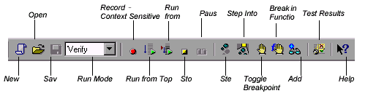
Standard Toolbar
The User toolbar displays the tools you frequently use to create test scripts. By default, the User toolbar is hidden. To display the User toolbar, choose Window > User Toolbar. When you create tests, you can minimize the Win Runner window and work exclusively from the toolbar.
The User toolbar is customizable. You choose to add or remove buttons using the Settings > Customize User Toolbar menu option. When you re-open Win Runner, the User toolbar appears as it was when you last closed it.

The commands on the Standard toolbar and the User toolbar are described in detail in subsequent lessons.
Note that you can also execute many commands using soft keys. Softkeys are keyboard shortcuts for carrying out menu commands. You can configure the soft key combinations for your keyboard using the Soft key Configuration utility in your Win Runner program group. For more information, see the “Win Runner at a Glance” chapter in your Win Runner User’s Guide.
Now that you are familiar with the main Win Runner window, take a few minutes to explore these window components before proceeding to the next lesson.
The Test Window
You create and run Win Runner tests in the test window. It contains the following
key elements:
- Test window title bar, with the name of the open test
- Test script, with statements generated by recording and/or programming in TSL, Mercury Interactive Test Script Language
- Execution arrow, which indicates the line of the test script being executed during a test run, or the line that will next run if you select the Run from arrow option
- Insertion point, which indicates where you can insert or edit text
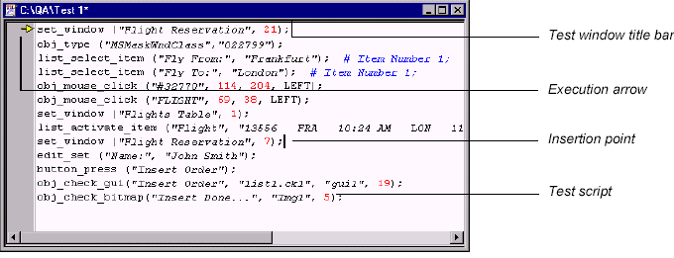

Result: Thus the win runner tool and its implementation are successfully studied.

Exp.No. 7 | CREATING A TEST CASE
Dt. | CREATING A TEST CASE

AIM: Write the test cases for any Login page of any website (e.g. GMAIL application )
DESCRIPTION:
- Verify that the login screen is having option to enter username and password with submit button and option of forgot password
- Verify that user is able to login with valid username and password
- Verify that user is not able to login with invalid username and password
- Verify that validation message gets displayed in case user leaves username or password field as blank
- Verify that validation message is displayed in case user exceeds the character limit of the user name and password fields
- Verify that there is reset button to clear the field's text
- Verify if there is checkbox with label "remember password" in the login page
- Verify that the password is in encrypted form when entered
- Verify that there is limit on the total number of unsuccessful attempts
- For security point of view, in case of in correct credentials user is displayed the message like "incorrect username or password" instead of exact message pointing at the field that is incorrect. As message like "incorrect username" will aid hacker in bruteforcing the fields one by one
- Verify the timeout of the login session
- Verify if the password can be copy-pasted or not
- Verify that once logged in, clicking back button doesn't logout user

Result: Thus the test case for any login page (GMAIL Application) is written successfully.

DEPARTMENT OF COMPUTER SCIENCE & ENGINEERING

PROGRAM EDUCATIONAL OBJECTIVES (PEOs):
- Develop expertise in logical reasoning, analysis and design to solve Computer Science and Engineering problems
- Competent to work as an individual or team member contributing to research and solve real world problems
- Involve in multi disciplinary teams by indulging interpersonal skills and ethical behavior
- Engage in Life Long Learning for career enhancement and professional growth

PROGRAMME SPECIFIC OBJECTIVES (PSOs):
- Professional Knowledge: Analyse and apply the concepts of Algorithms, Web Technologies and Data Analytics to meet specified requirements
- Software Skills: Design and implement solutions for computing problems using Java, PHP, Python and Big Data technologies

PROGRAM OUTCOMES (POs):
Computer science & Engineering Graduates will be able to:
- Engineering knowledge: Apply the knowledge of mathematics, science, engineering fundamentals, and an engineering specialization to the solution of complex engineering problems in Computer Science and Engineering.
- Problem analysis: Identify, formulate, review research literature, and analyse complex engineering problems reaching substantiated conclusions using first principles of mathematics, natural sciences, and engineering sciences.
- Design/development of solutions: Design solutions for complex engineering problems and design system components or processes that meet the specified needs with appropriate consideration for the public health and safety, and the cultural, societal, and environmental considerations.
- Conduct investigations of complex problems: Use research-based knowledge and research methods including design of experiments, analysis and interpretation of data, and synthesis of the information to provide valid conclusions.
- Modern tool usage: Create, select, and apply appropriate techniques, resources, and modern engineering and IT tools including prediction and modelling to complex engineering activities with an understanding of the limitations.
- The engineer and society: Apply reasoning informed by the contextual knowledge to assess societal, health, safety, legal and cultural issues and the consequent responsibilities relevant to the professional engineering practice.
- Environment and sustainability: Understand the impact of the professional engineering solutions in societal and environmental contexts, and demonstrate the knowledge of, and need for sustainable development.
- Ethics: Apply ethical principles and commit to professional ethics and responsibilities and norms of the engineering practice.
- Individual and team work: Function effectively as an individual, and as a member or leader in diverse teams, and in multidisciplinary settings.
- Communication: Communicate effectively on complex engineering activities with the engineering community and with society at large, such as, being able to comprehend and write effective reports and design documentation, make effective presentations, and give and receive clear instructions.
- Project management and finance: Demonstrate knowledge and understanding of the engineering and management principles and apply these to one’s own work, as a member and leader in a team, to manage projects and in multidisciplinary environments.
- Life-long learning: Recognize the need for, and have the preparation and ability to engage in independent and life-long learning in the broadest context of technological change.

